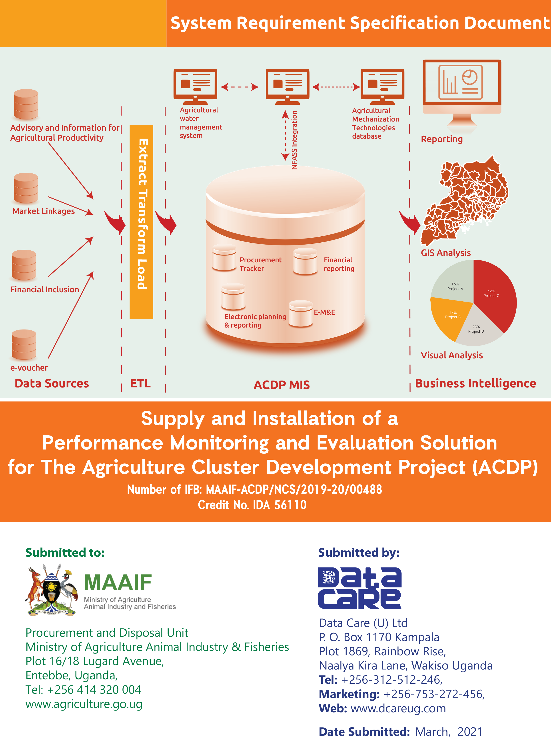

**Supply and Installation of a Performance Monitoring and Evaluation Solution for**

**The Agriculture Cluster Development Project [ACDP]**

System

Requirement

Specification Document

Number of IFB: MAAIF-ACDP/NCS/2019-20/00488

Credit No.: IDA 56110

***Submitted by:***



Data Care (U) Ltd.

P.O. Box 1170 | Kampala | Plot 1869

Rainbow Rise | Naalya Kira Lane | Wakiso – Uganda

Tel: +256 312 512 246

**Marketing:** +256 753 272 456

**Web**:www.dcareug.com

**Date:** March 2021

***Submitted to:***



Procurement and Disposal Unit

Ministry of Agriculture Animal Industry & Fisheries

Plot 16/18 Lugard Avenue

Entebbe-Uganda

Tel: +256 414 320 004

**Web**:www.agriculture.go.ug

**Table of Contents**

About This Document iv

Revision History iv

Acronyms v

1.0 Introduction 1

1.1 Purpose 1

1.2 Project Abstract 2

1.3 Document Objective 2

1.4 References 2

2.0 Background 4

2.1 Scope of Work 4

2.2 Product Perspective 5

2.3 Environmental Considerations 8

2.4 Design and Implementation Constraints 8

2.5 User Documentation 8

2.6 Assumption and dependencies 9

2.7 Hardware and Software requirements 9

3.0 Requirements for the delivery of the Management Information Systems 11

3.1 Business Requirements 11

3.2 Requirements for the ACDP MIS 14

3.3 Requirements for Agriculture Water Management Information System (AWMIS) 15

3.4 Requirements for Agriculture Mechanization Technologies Information System (AMTIS) 16

4.0 User Classes and Characteristics 18

5.0 Functional Requirements 19

5.1 Homepage and Navigation 19

5.2 Data Collection and Synchronization 19

5.3 Search Function 19

5.4 User-Level Validation 19

5.5 GIS Functions 20

5.6 Reports & Data Visualization 20

5.7 Data Export/Import 21

5.8 Asset Management 21

5.9 Document Management 21

5.10 Other Functional Requirements 21

6.0 Non-Functional requirements 22

6.1 Supportability/adaptability 22

6.2 Reliability 22

6.3 Safety 22

6.4 Usability 22

6.5 Performance and robustness 22

6.6 Security 22

6.7 Interoperability 23

6.8 Scalability 23

6.9 Maintainability 23

7.0 Use cases 25

7.1 User Login 26

7.2 Data capture tools download 27

7.3 Survey Data capture 29

7.4 GPS coordinates data capture 30

7.5 Photo capture 32

7.6 Record Management 34

7.7 Data Synchronization 36

7.8 View and download documents 38

7.9 Administrator Login 41

7.10 Configure data collection tools 43

7.11 User Management 45

7.12 Verify Data 47

7.13 Configure reports 49

7.14 Manage Document Repository 51

7.15 Manage GIS 53

7.16 Interoperability 55

**List of Tables**

**Table 1.1:** Project Abstract 2

**Table 2.1:** Environmental Considerations 8

**Table 2.2:** Web-based MIS Requirements 9

**Table 2.3:** Mobile Data Collection Application Requirements 10

**Table 4.1:** ACDP MIS User Classes and Characteristics 18

**Table 7.1:** User Login Use Case description 26

**Table 7.2:** Data capture tools selection Use Case description 28

**Table 7.3:** Survey Data capture Use Case description 29

**Table 7.4:** GPS coordinates data capture Use Case description 31

**Table 7.5:** Photo capture Use Case description 33

**Table 7.6:** Record Management Use Case description 35

**Table 7.7:** Data Synchronization Use Case Description 37

**Table 7.8:** View and download documents Use Case description 39

**Table 7.9:** Administrator Login Use Case description 42

**Table 7.10:** Configure data collection tools Use Case description 44

**Table 7.11:** User management Use Case description 46

**Table 7.12:** Verify Data Use Case description 48

**Table 7.13:** Configure reports Use Case Description 50

**Table 7.14:** Manage Document Repository Use Case description 52

**Table 7.15:** Manage GIS Function Use Case description 54

**Table 7.16:** Interoperability Use Case description 56

**List of Figures**

**Figure 2.1:** Scope of Work 4

**Figure 3.1:** The ACDP MIS Features 15

**Figure 3.2:** The AWMIS Features Mapping 16

**Figure 3.3:** The AMTIS Features Mapping 17

**Figure 7.1:** The MAAIF/ACDP Use Cases 27

**Figure 7.2:** User Login Use Case diagram 28

**Figure 7.3:** Data Capture Tools (pull from server) use case diagram 29

**Figure 7.4:** Survey Data capture Use Case diagram 31

**Figure 7.5:** GPS coordinates data capture Use Case diagram 33

**Figure 7.6:** Photo capture Use Case diagram 34

**Figure 7.7:** Record Management Use Case 36

**Figure 7.8:** Synchronize data (push to server) Use Case diagram 38

**Figure 7.9:** View and Download Documents Use Case diagram 40

**Figure 7.10:** The Administrator Use Cases 42

**Figure 7.11:** Administrator Login Use Case diagram 43

**Figure 7.12:** Configure Data Capture Tools Use Case diagram 45

**Figure 7.13:** User management Use Case diagram 47

**Figure 7.14:** Verify Data Use Case diagram 49

**Figure 7.15:**  Configure Reports Use Case diagram 51

**Figure 7.16:** Manage Document Repository Use Case diagram 53

**Figure 7.17:** Manage GIS Function Use Case diagram 55

**Figure 7.18:** Interoperability Use Case 57

**List of Annexes**

**Annex I:** Technical Requirements Specifications 57

**Annex II:** Testing and Quality Assurance Requirements 67

**About This Document**

|  |  |
| --- | --- |
| **Purpose of this Document** | This document, the Systems Requirement Specification (SRS) is designed to express the behavioral, performance, and development requirements of Performance Monitoring and Evaluation Solution for Data Analytics, Financial Reporting, Procurement Tracker and Monitoring and Evaluation. It serves as the fundamental requirements document for the development of the product. It includes a description of every input into the system, every output from the system and all functions performed by the system in response to input or in support of an output. The SRS is the exclusive requirements document to be used in design, development and testing of the Performance Monitoring and Evaluation Solution for Data Analytics. |
| **Document Prepared for** | Ministry of Agriculture, Animal Industry and Fisheries |
| **Intended Audience** | Ministry and ACDP Project Staff, System Designers, Testers, Users and Trainers |
| **Date of Publication** | Last saved: 26-03-2021 |
| **Page Count** | 90 pages |
| **Prepared by** | Data Care (U) LTD |
| **Copyright Notice** | Permission to make digital or hard copies of all of this work for personal or other use is granted by the Ministry of Agriculture, Animal Industry and Fisheries. |

# **Revision History**

|  |  |  |  |
| --- | --- | --- | --- |
| **Date** | **Revision** | **Description** | **Author** |
| **26/03/2021** | **1.0** | **Draft Version 1.0 for review by the ACDP and MAAIF Team** | **Data Care** |
|  |  |  |  |
|  |  |  |  |
|  |  |  |  |

# **Acronyms**

ACDP Agricultural Cluster Development Project

AMTIS Agriculture Mechanization Technologies Information System

API Application Programming Interface

ASSP Agriculture Sector Strategic Plan

AWMIS Agriculture Water Management Information System

BI Business Intelligence

DAT Disruptive Agricultural Technological

ETL Extraction, Transformation and Loading

GIS Geographical Information Systems

GOU Government of Uganda

MAAIF Ministry of Agriculture, Animal Industry, and Fisheries

MDAs Ministries, Departments and Agencies

MIS Management Information System

NIMP National Irrigation Master Plan

NFASS National Food and Agricultural Statistics System

PAD Project Appraisal Document

RAADRS Routine Agricultural Administrative Data Reporting System

SRS System Requirements Specifications

ToR Terms of Reference

# **1.0 Introduction**

## 1.1 Purpose

The Ministry of Agriculture, Animal Industry and Fisheries (MAAIF) received funding from the World Bank towards the cost of the Agriculture Cluster Development Project (ACDP). ACDP is uniquely designed to leverage digital and disruptive Agricultural Technologies, delivering agricultural services to farmers. This project has been met with many challenges such as delays in the development of the applications and system failures which has affected farmer group registration, farmer enrolments, farmer access to project information and agricultural extension, project implementation and monitoring, and data analytics. The existing solution does not address the needs of MAAIF/ACDP project. On this basis, the MAAIF through the Disruptive Agricultural Technological (DAT) Innovation Challenge selected Data Care to provide technological applications to turn around the project performance, through automation of key business processes along the value chain, as well as improving service delivery to the intended project beneficiaries.

The main objective of the requirement for which Data Care has been selected is to enhance the functionality of the existing solution as presented at the proof-of-concept workshop, by bridging the identified gaps to offer an all-inclusive Performance Monitoring and Evaluation System, to facilitate delivery of the project.

This will entail development of an MIS with functionalities which will include among others electronic planning and reporting, financial reporting, monitoring and evaluation, procurement tracking and management of matching grants. Agriculture Water Management Information System (AWMIS) and Agriculture Mechanization Technologies Information System (AMTIS) will form part of the development. The MIS will be integrated with other relevant tools such as Geographical Information Systems (GIS). All integrated modules/tools will provide data collected into the NFASS database.

The specific objectives are:

1. To enhance the System to address the gaps identified at the proof of concept workshop, highlighted under scope of assignment in this document, and present a comprehensive application;
2. To provide user training and requisite operational manuals for the system;
3. Provide technical support and maintenance of the platform for a specified period of time as highlighted under the list of deliverables

This document expresses the development requirements, behavioral and performance of the Performance Monitoring and Evaluation Solution for Data Analytics, Financial Reporting, Procurement Tracker and Monitoring and Evaluation. It therefore, serves as the fundamental requirements document for the development of the product. It includes a description of every input into the system, every output from the system and all functions performed by the system in response to input or in support of an output. The SRS is the exclusive requirements document to be used in development; all design and testing choices will be compatible with this document.

## 1.2 Project Abstract

**Table 1.1: Project Abstract**

|  |  |
| --- | --- |
| **Project Name:** | Ministry of Agriculture, Animal Industry, and Fisheries,  Agriculture Cluster Development Project (ACDP).  Performance Monitoring and Evaluation Solution for Data Analytics |
| **Customer Departments:** | ICT, Monitoring and Evaluation, Matching Grants, Procurement, Finance, Statistics, GIS |
| **Authors:** | Data Care |
| **Date:** | 26/03/2021 |

## 1.3 Document Objective

The SRS document identifies the magnitude of what Performance Monitoring and Evaluation Solution for Data Analytics, Financial Reporting, Procurement Tracker and Monitoring and Evaluation will cover. The document is intended for review by the Ministry of Agriculture, Animal Industries and Fisheries/ACDP to ensure that all desired functional, performance and development requirements have been included as identified in the gap analysis and the terms of reference (Annex 1). The document is expected to minimize misinterpretations by developers and testers by using clear, concise, unambiguous, and complete language. It will be used for strategies in Master Test Plan, Functional Test Plan, and other formal testing documents. During development where there are any inevitable changes, the SRS will be modified accordingly.

The SRS document will be used as a living document during the development and after project is completed for operations and maintenance to obtain a greater understanding of the system whenever any changes need to be made. Adherence to this document shall be enforced to ensure that it is coherent with the business requirements. This will ensure components, responsibilities, and test cases link to minimize impact and avoid requirements changes and localize defects. This document will form a background to the user and technical manual documentation.

## 1.4 References

1. The Agriculture Sector Strategic Plan (ASSP)
2. The National Irrigation Master Plan (NIMP)
3. Project Appraisal Document (PAD) and restructuring report
4. Project Implementation Manual
5. Report of Baseline survey for ACDP
6. Results Framework, annual targets indicators and monitoring tools for the various programs, agencies and projects of the Ministry.
7. NFASS Project Documents
8. National Standards Indicators Matrix

# **2.0** **Background**

The Government of Uganda (GOU), through the Ministry of Agriculture, Animal Industry and Fisheries (MAAIF) received funding from the World Bank towards the cost of the Agriculture Cluster Development Project (ACDP). The project objective is to raise on-farm production, productivity, and marketable volumes of **Beans, Rice, Maize, Cassava** and **Coffee**, in twelve geographical clusters, making up fifty-five districts. ACDP is uniquely designed to leverage digital and disruptive Agricultural Technologies, delivering agricultural services to farmers including; input subsidies, extension, market information, and others through innovations such as e-vouchers, e-wallet, e-extension, e-diary, e-statistics, and Management Information Systems (MIS).

The project has met various challenges in the implementation such as: delays in the development of the applications and system failures which has affected farmer group registration, farmer enrolments, farmer access to project information and agricultural extension, project implementation and monitoring, and data analytics. These challenges have slowed the progress of the project towards the realization of the development objective.

It is expected that the solution to be developed should turn around the project performance, through automation of key business processes along the value chain, as well as improving service delivery to the intended project beneficiaries. The ACDP challenges were categorized as Advisory and Information for agricultural productivity, Market Linkages, Financial Inclusion, and Data Analytics. This consultancy is to provide a solution on Data Analytics, Financial Reporting, Procurement Tracker; and Monitoring and Evaluation of which this SRS will focus on its requirements.

## 

## 2.1 Scope of Work

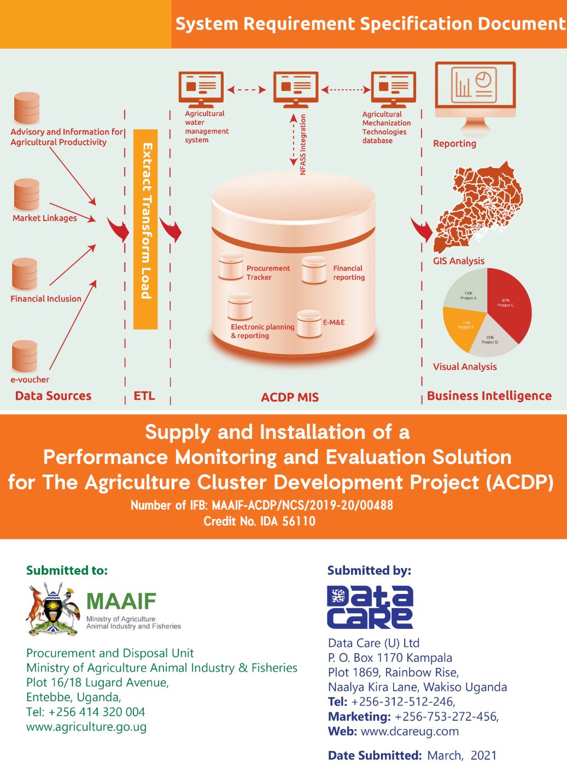

**Figure 2.1:** **System Scope**

The scope of this assignment shall be to present the complete current system functionality and address the gaps identified under areas for enhancement in the data analytics function as follows;

* Develop an effective, efficient, expandable and interoperable MIS that integrates and is compatible with existing systems in the project
* Ensure that the MIS is capable of providing quick analysis (dashboard capability) of trends and comparisons against defined indicators at various levels.
* Develop mechanism for ensuring effective internal coordination within the project functions such as planning, finance, administration, procurement, M&E
* Develop an Agricultural Water management Information System (AWMIS)
* Develop an Agriculture Mechanization Technologies Information System (AMTIS)
* Ensure that the AWMIS and AMTIS are integrated with the National Food and Agricultural Statistics System (NFASS).
* Train key staff members of the project on the developed systems
* Develop an MIS user manual / guiding document for sustainability purposes
* Provide support to the system users for a specified period of time
* Support and enhance the functionality of the NFASS as shall be described by MAAIF

## 2.2 Product Perspective

The ACDP MIS will provide an all-inclusive performance Monitoring and Evaluation system that will facilitate the delivery of the ACDP project. The ACDP MIS will have modules such as a procurement tracker, a financial reporting platform, electronic planning and reporting platform and an electronic monitoring and evaluation system.

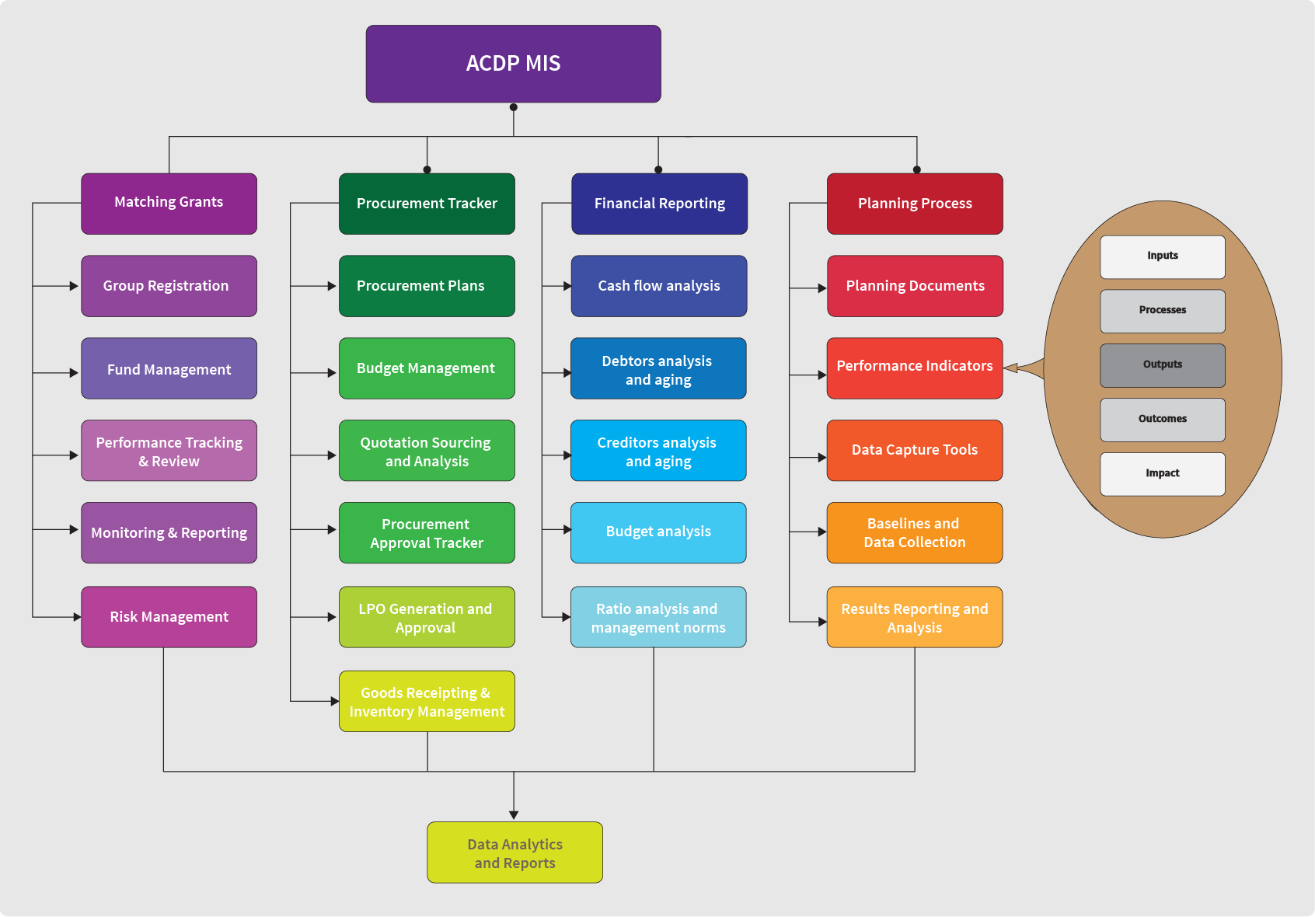

**Figure 2.2:** **Features of the ACDP MIS modules**

The features of the different modules of the ACDP MIS are described in sections 2.2.1 to 2.2.5

**2.2.1 Procurement Tracker Module**

The Procurement Tracker will allow users to monitor the process of procuring goods and services within the project. It provides information about:

1. The overall project procurement plan and budget for the project for a defined period.
2. The user and department requesting the procurement
3. The procurement reference for the item or service being requested for
4. The dates when the goods or services are required by the user/department
5. The budget/financing plan against which the procurement is being made
6. The detailed description of the product/service being procured
7. The quantities of the product/service to be procured
8. The estimated cost of the goods/services at the time of requisition
9. Quotation Sourcing and Analysis
10. The actual cost of obtaining the goods/services
11. Approval history/tracker for each procurement.
12. The amount of time spent at any one approval point
13. LPO Generation and Approval
14. The dates at which the goods/services where obtained
15. Goods Receipting & Inventory Management

The procurement tracker will ensure reviewing, ordering, delivery, and billing management for goods, services and works involved in the procurement process.

The reports to be generated from the procurement tracker include:

1. Total value of commitments by period (LPOs issued)
2. Total value in the pipeline (no. of LPOs)
3. Total value of LPOs received
4. Purchases made by category by period
5. Value of purchases by suppliers by period
6. Orders by department by period
7. Work plan report
8. Planned expenditure by category
9. Planned vs. Actual expenditure by procurement category
10. Planned expenditure by item grouping
11. Consolidated procurement plan

**2.2.2 Financial Reporting Module**

The Financial Reporting module within the ACDP MIS aims to aid users within the Finance department to keep track of and meet the financial obligations of the project as those obligations fall due. It is to support using the least possible amount of financial resources within the limits of some predetermined margin of safety. The Financial reporting module will enable:

1. Cash flow analysis
2. Track sources and uses of funds
3. Debtors analysis and aging
4. Creditors analysis and aging
5. Budget analysis
6. Ratio analysis and management norms.
7. Capital budgeting and ranking of investment alternatives.
8. Maintenance cost analysis.
9. Creation of custom Ad-hoc and financial reports

**2.2.3 Electronic Planning and Reporting / Monitoring and Evaluation Module**

The planning, reporting, and monitoring and evaluation module will be useful for storage, retrieval and analysis of performance data utilized for reporting and learning. Project level performance data will be captured in the MIS and later aggregated on quarterly basis to provide performance data segregated by interventions and other variables e.g. gender, district, and as per requirements. The module will be designed to capture both quantitative and qualitative data.

The MIS will offer a platform for documenting processes, outcomes and results that will enhance effectiveness and efficiency of implementation, provide an avenue for monitoring and evaluating performance of interventions, and provide information that will support impact measurement of the ACDP project.

The ACDP MIS will have the ability to capture (by multiple users, teams, and sources), process and avail an access point for authorized parties. The system will have the ability to handle large volumes of data (Quantitative and Qualitative) and above all be flexible in facilitating data analysis.

The system will offer a cross cutting set of tools that will facilitate Data Collection, Entry/Reporting, Analysis and Sharing.

**2.2.4 Matching Grants Module**

This module will support the management and implementation of the Matching Grants Fund. The module will promote efficiency and effectiveness of the Matching Grants function of ACDP and support risk management by tracking challenges faced by grantees during the implementation of the fund together with. Financial and narrative reporting will be done in real time, together with any project revisions. The system provides for real time tracking of processes, tasks, reminders and feedback.

The reports to be generated from the Matching Grants Module include:

1. Funded Structures
2. Funded Equipment
3. Monthly disbursements per Grantee
4. Annual Disbursements Schedule
5. Full Financing Expense Report
6. Co-financing Expense Report

**2.2.4 Online/Offline Data Entry**

Data Care will develop a mobile version of the ACDP MIS application that allows offline collection of data. The application will have a functionality which enables gathered data to be synchronized later with the aggregation server after getting an internet connection to ensure reliability of the tools and continuity of the ACDP processes. The project routine monitoring tools will be deployed with web forms that can be filled and data saved through a web enabled platform.

**2.2.5 Data Analytics**

The data analytics function will be delivered in three different Management Information Systems namely:

1. Agricultural Cluster Development Project Management Information System (ACDP MIS)
2. Agriculture Water Management Information System (AWMIS)
3. Agriculture Mechanization Technologies Information System (AMTIS)

The National Food and Agricultural Statistics System (NFASS) MIS was already developed but the scope of this consultancy requires that Data Care enhances the functionalities and provides routine support. The enhancement will include among others development of the offline data collection platform to feed the Routine Agricultural Administrative Data Reporting System (RAADRS) of the NFASS database. The ACDP MIS, AWMIS and AMTIS will all provide input into the NFASS database.

## 2.3 Environmental Considerations

**Table 2.1:** **Environmental Considerations**

|  |  |
| --- | --- |
| **Serial** | **Description** |
| EC-1 | The MIS shall operate with the following Web browsers: Google Chrome 56–86, Firefox 10–17, Internet Explorer 10, Maxthon 4.0, SeaMonkey 2.7-2.14, Opera 12, Safari 6 |
| EC-2 | The web-based MIS shall operate on a server with the specifications shown in Table 3.0. |
| EC-3 | The mobile data collection application will operate on Android devices (mobile phones or tablet PC’s) with the specifications shown in table 4.0. |
| EC-4 | The web-based MIS shall permit user access over the internet. |

## 2.4 Design and Implementation Constraints

**CO-1:** The MIS will be built using MS .Net programming language

**CO-2:** The MIS system’s design and code will conform to the Model-View-Controller (MVC) architectural pattern.

**CO-3:** All HTML code shall conform to the HTML 4.0 standard.

**CO-4:** The MIS will run on application servers IIS 7.5**CO-5:** The MIS will use MSSQL for Database Management in order to interface well with the in-house MySQL.

## 2.5 User Documentation

User manuals and technical documentation will be delivered along with the software. The user manual will be in Microsoft word document (DOC) and PDF versions, with detailed screen captures showing the MIS at different stages.

## 2.6 Assumption and Dependencies

A number of factors that may affect the requirements specified in the SRS include:

* Users of the mobile data collection application are accustomed to the paper-based data collection tools. For this reason the users will need to go through the training documents or undergo training to understand how the application works.
* The application is dependent on the availability of an Android Phone to be installed.
* The application users adhere to the application’s minimum software and hardware requirements.
* The AWMIS, ACDP MIS and AMTIS will be integrated with the NFASS Database. The ACDP MIS will be integrated with the MAAIF eVoucher system and the AWMIS with the Micro-Scale Irrigation Information System.
* The MAAIF project team will participate in the weekly progress review meetings to give feedback on prototypes and provide clarity on requirements.
* MAAIF will procure and configure tablet computers to enable collection of the data by the Data Collection officers / interviewers.
* The Tablet PCs will require an internet connection to download the MIS mobile application from the Google play store and to configure their application for use.
* Data collection can then occur offline (without an internet connection) however, in order to upload the collected data onto the web-based MIS, the tablet pc will also require an internet connection.

## 2.7 Hardware and Software requirements

**Table 2.2: Web-based MIS Requirements**

| **No.** | **Key Requirement** | **Minimum Requirement** | **Recommended** |
| --- | --- | --- | --- |
|  | Operating System | Windows OS Server 2013 | Windows Server 2016 or Greater |
|  | Database Management System | MSSQL 2012 | MSSQL 2012 |
|  | Web Server | IIS 8 | IIS 8 |
|  | Web Server Dependencies | .Net Framework 4.0 | .Net Framework 4.6 or higher |
|  | Memory | 16 GB | 64 GB or greater |
|  | Processor Speed | 8 GHz (x64 processor) | 8 GHz (x64 processor) |
|  | Hard Drive Capacity | 1 Terabyte | 5 Terabyte or Higher |
|  | Processor Speed | 8 GHz | 8 GHz or Higher |
|  | Remote Access: FTP Access and Team Viewer Access where applicable | 1. FTP Access 2. Team Viewer Access 3. Remote Desktop Connection |  |
|  | Internet Connectivity | 1. Internet required 2. NATed IP address 3. Public IP address 4. Domain Name 5. SSL Certificate 6. Port 80 to be Opened | 1. Internet required 2. NATed IP address 3. Public IP address 4. Domain Name 5. SSL Certificate 6. Port 80 to be Opened |

**Table 2.3: Mobile Data Collection Application Requirements**

|  |  |  |  |
| --- | --- | --- | --- |
| **No.** | **Key Requirement** | **Minimum Requirement** | **Recommended** |
|  | Operating System | Android 7.1 | Android 10 or above |
|  | WLAN | Wi-Fi 802.11 a/b/g/n/ac, dual-band, Wi-Fi Direct, hotspot | Wi-Fi 802.11 a/b/g/n/ac, dual-band, Wi-Fi Direct, hotspot |
|  | SIM Card | Yes, Nano Sim | Yes, Nano Sim |
|  | GPS | Yes, with A-GPS, GLONASS, GALILEO, BDS | Yes, with A-GPS, GLONASS, GALILEO, BDS |
|  | Camera | 8 MP, f/1.9, AF | 8 MP, f/2.0, AF or higher |
|  | Internal Memory | 8 GB | 16 GB or greater |
|  | Processor | Quad-core 1.4 GHz | Octa-core (2x1.8 GHz) |
|  | RAM | 4 GB | 8 GB |
|  | Processor Speed | 8 GHz | 8 GHz or Higher |
|  | Sensors | Accelerometer, ANT+ | Accelerometer, gyro, compass, ANT+ |
|  | Network | GSM / HSPA / LTE | GSM / HSPA / LTE |
|  | Battery | Li-Ion 5000 mAh | Li-Po 6150 mAh or higher |

# **3.****0 Requirements for the delivery of the Management Information Systems**

## 3.1 Business Requirements

**3.1.1 Technology and Application Access**

* The system shall be an integration of the identified system components accessed through a web – based platform and portable devices such as smart phones and tablet computers.
* The system shall be accessible through the common web browsers such as Chrome, Mozilla firefox and Internet explorer.
* The system should support development of required modules such as finance, procurement, e-planning and reporting, an e-M&E Management Information System (e-M&E MIS) that enables electronic planning and reporting (annual, quarterly and monthly) at the district and national level.
* Other systems to be developed shall include Agriculture Mechanization Technologies Information System (AMTIS), Agriculture Water Management Information System (AWMIS) and interfaces to pull data from external data sources.
* All activities as shall be defined by MAAIF management should be initiated through the system to ease performance tracking

**3.1.2 Data Collection**

* Development of data collection tools required to aggregate data on project performance across components
* Improvement of existing data collection tools including customisation of the tools to address emerging and specific data needs
* The system should have a well-defined path and interface from the external data sources to data warehouse through the ETL function.
* The system should be able to capture details of the different suppliers, service providers and other players doing supplies to the MAAIF with their respective activities such as supplying of AMTs, maintaining them and disposing them off.
* In the case of AMTIS the system should be able to capture specifications of different AMTs, their sources, certification details and application guidelines and it must be scalable in nature to allow feature additions and or subtractions, for adaptation to other MAAIF interventions.
* The system shall enable regular content updates by MAAIF staff through manual data entry, real time web based or mobile technologies.
* The data collected should be geo-referenced.

**3.1.3 Data Synchronization**

* The system should enable synchronization of data captured offline when a connection is available.

**3.1.4 Reporting**

* The solution should have the ability for querying, filtering and doing analysis based on specified variables. It should be able to produce periodic and on demand formatted reports as may be specified by the user.
* The system should support aggregation of routine monitoring data and ability to download the data and manipulate it outside the system.
* It should support generation of reports that includes service/facilities delivery at national, local government and lower local government levels.
* Present a dashboard of key project performance indicators in line with the project results framework. Automate measuring of progress made against the set targets on a periodic basis.
* The ability to visualize time series data, plotting functionality to support decision-making.

**3.1.5 Interoperability**

* Provide for integration with any data collection systems within the project and MAAIF, storage and management of the data that is parsed from the system(s).
* The system shall be compatible with the overall MAAIF Agriculture Information Management System.
* The system shall be able to import data from other applications outside MAAIF and ACDP.
* To enhance interoperability, the system should be ready to consume APIs from external applications to enable integration with ACDP/ MAAIF systems.

**3.1.6 GIS integration**

* The system should enable capture, storage and visualization of Geo tagged data. The functionality should allow for (i) GIS data management (Database and interactive Visualization), (ii) Ability to upload shapefiles and rasters, (iii) ability to consume already provided map services, populate with needed information and print (iv) Ability to export and download GIS data and GIS products in PDF format (v) generate maps.
* The system shall enable interactive visualization of map content with functionality such as hover over, pop-ups of attribute information, zoom in and zoom out, among others.
* The system should enable offline collection of routine data with geospatial meta data initiated through an android app.
* The system shall enable downloading and sharing spatial data, PDF map CSV, and zipped files including a search and filter capability by logged in users.
* The system shall import point data to allow plotting using the national polygon data.

**3.1.7 The future**

* The system shall be able to support emerging technologies and new trends on data analytics, artificial intelligence and machine learning.

**3.1.8 System Administration**

* It should be able to distinguish roles and rights for each type of user as defined by the systems administrator.
* The system should be able to provide a log of activities performed in it.

On the basis of the business requirements, Data Care derived the functional and non-functional requirements and the use cases. The expected system will conform to the specifications outlined in the respective Terms of References (ToR) documents (Annex 1). It will incorporate extensions that will be introduced during the design stage. The specification of the requirements shall be outlined individually for the three different management information systems.

The current business process is such that;

1. Data is collected by various Departments of MAAIF, MAAIF Agencies and District Local Governments. This data remains a product of the organization that collected it, and will make own analysis of it to inform decision making.
2. Data is collected in different formats by different users
3. Planning and reporting for the project is done manually at national and district level.
4. Standardized routine monitoring tools are developed with potentially large data sets to be collected
5. There are numerous reporting requirements for different stakeholders

The problems identified with such a business process are that;

1. There is limited sharing of information between institutions hence affecting planning, reporting, monitoring and evaluation for increased crop production, processing, value addition and marketing
2. There is lack of a central repository by the sector for statistical data
3. Data collection is still paper based, and is not geo-referenced
4. There is lack of a functional management information system that allows electronic planning and reporting for the project at both the national and district level
5. There is lack of a centralized database for all project and MAAIF data
6. The process of reporting to different stakeholders is tedious

During the SRS data gathering, the following were covered as required by the Client;

1. Determination of stakeholders (all who have a role in data acquisition, processing, reporting, or use/decision making)
2. Determination of a detailed system performance and monitoring measurable indicators
3. Review of the existing documents including the Agriculture Sector Strategic Plan (ASSP), Project Appraisal Document (PAD) and restructuring report, Project Implementation Manual, Report of Baseline survey for ACDP, Results Framework, annual targets indicators and monitoring tools for the various programs, agencies and projects of the Ministry
4. Review of the descriptive document (concept notes, system requirements documents, others) to better understand the types of data and information products that will be incorporated into the database
5. Review of the existing staff capacities, procedures, tools, and data processes
6. Definition of the hardware and software requirements

## 3.2 Requirements for the ACDP MIS

**3.2.1 System Purpose**

The main objective of the requirement is to enhance the functionality of the existing solution as presented by Data Care at the proof of concept workshop, by bridging the identified gaps to offer an all-inclusive Performance Monitoring and Evaluation System that will facilitate the delivery of the project.

The functions of the ACDP MIS is as shown in **Figure 3.1**.

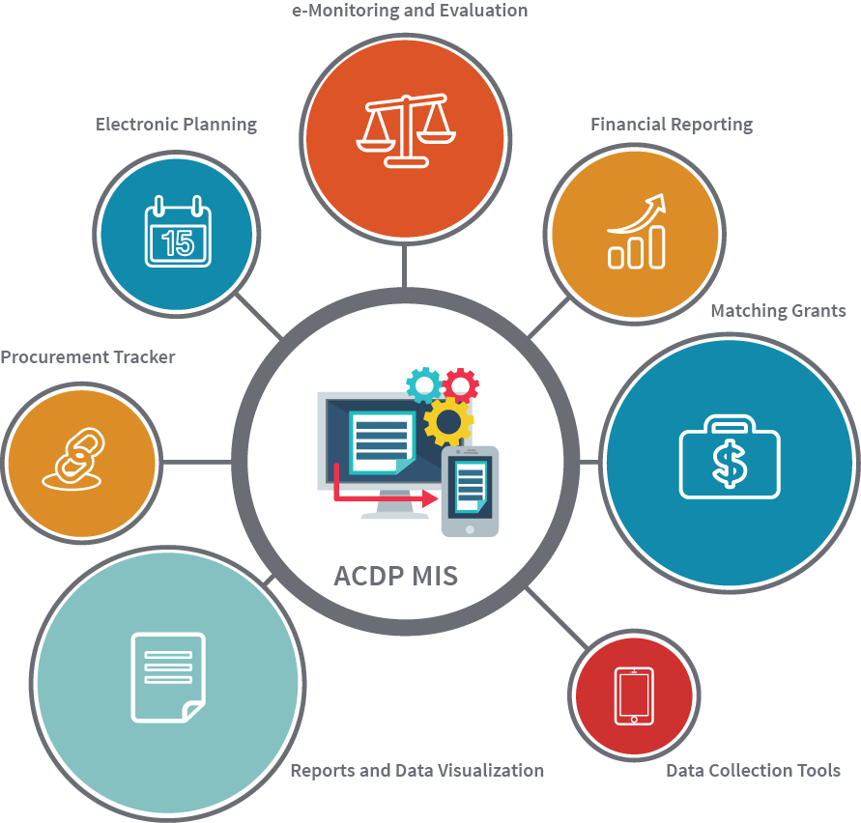

**Figure 3.1:** **The ACDP MIS Functions**

## 3.3 Requirements for Agriculture Water Management Information System (AWMIS)

**3.3.1 System Purpose**

The requirement is to compile, design and develop a GIS web based Agriculture Water Management Information System (AWMIS) as a component of the overall integrated web-based Agricultural Management Information System (AMIS). The AWMIS is expected to provide a platform for visualization of spatial distribution of Agriculture water data and information there by improving service delivery through timely provision of accurate, well- organized data, to support evidence based decision making by various stakeholders.

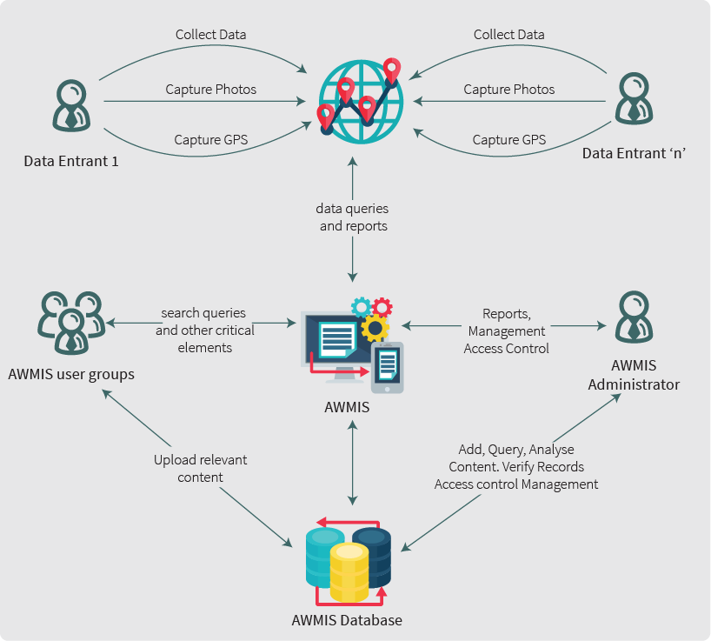

**Figure 3.2:** **The AWMIS Features Mapping**

## 3.4 Requirements for Agriculture Mechanization Technologies Information System (AMTIS)

**3.4.1 System Purpose**

The main objective of the assignment is to design and develop a web based Information Management System for Mechanization Technologies under the Ministry of Agriculture that will act as a registry, inventory and assist the division in tracking implementation, and measuring effectiveness of the sector interventions in increasing access, utilization and adoption of Agricultural Mechanization Technologies (AMTs). This will provide an opportunity to management to obtain information and measure performance of different players in Mechanization against targets in real time.

**Figure 3.3: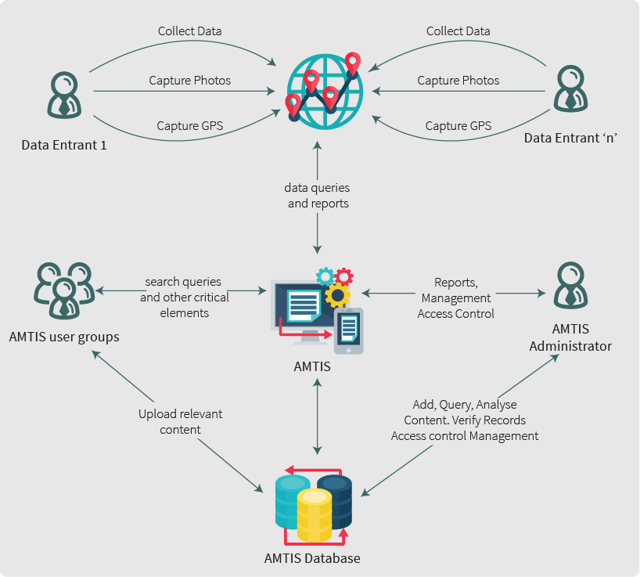 The AMTIS Features Mapping**

In the study of the requirements by Data Care, it was established that the User Classes and Characteristics, functional requirements and Use cases for ACDP MIS, AWMIS and AMTIS are similar. Therefore, the next sections are generalized to refer to the specified requirements for all the three management information systems.

# **4.0 User Classes and Characteristics**

The different system users are as defined in the preceding table (**Table 4.1**).

**Table 4.1:** **ACDP MIS User Classes and Characteristics**

| **No.** | **Categories of AWMIS Users** | **Description** | **Technical Expertise** | **Frequency of Use** |
| --- | --- | --- | --- | --- |
| 1. | MIS Administrator | Full access to all functionalities, including lower-level processes of the system, ability to configure survey tools, customize reports and data visualizations and Manage MIS User accounts. | High | Medium |
| 2. | MAAIF Supervisor | Access to all, including lower-level functionalities of processes of the system  Checking the accuracy of information input by the data entrants into the MIS, customize reports in the MIS. | High | High |
| 3. | Data Entrant / Extension Worker | Collection and entry of data in the MIS, Capture GIS coordinates of facilities, Capture photos, view data and reports. | Medium | High |
| 4. | District Engineers | Collection and entry of data in the MIS. Capture GIS coordinates of facilities, Capture photos, view data and reports. | Low | Low |

# **5.0 Functional Requirements**

## 5.1 Homepage and Navigation

**FR-01:** The system should enable users to view the Home page of the application and with navigation pane select suitable items, as they may prefer.

**FR-02:** The mobile app should have a data capture tool button, which on tapping enable users to view a list of data capture tools and select particular tool to facilitate data capture.

**FR-03:** The application should enable users to add/update/view/delete records  on the device marked as completed or not marked as completed or partially filled depending on the specific rights and roles of the user.

## 5.2 Data Collection and Synchronization

**FR-04:** The input screen should enable the user to enter date of record collection. It should also allow selection of a field they would like to input information onto it.

**FR-05:** The system should allow for capture/update of GPS coordinates as may be required. It should also be able to capture/update/delete a photo on the application as required.

**FR-06:** Completeness of data capture on every page before proceeding to the next page should be mandatory.

**FR-07:** The system should have a synchronization button on the home screen that activates download of the updated data capture tools, lookup tables and able to upload any captured records flagged as completed on tapping.

**FR-08:** Synchronize data on entry completion.  The synchronization of data activity triggers update onto the web-based platform.

## 5.3 Search Function

**FR-09:** The search function should enable users to search records by district, sub-county or parish as may be required. It should be able to search for a particular alpha-numeric value from the dropdown list of lookup values provided.

## 5.4 User-Level Validation

**FR-10:** The system should enable a user to view entry made on the form before a transaction is committed.

**FR-11:** Ability to send a response to the user on whether the survey / form is valid/completed before they can flag the form as complete at the captured record details page.

**FR-12**: In case of an error on a form, the system should return the error to the user for appropriate action.

**FR-13:** The system should display the number of response indicators on the captured record details page of the device.  This will show the number of records entered in the device for each tool.

**FR-14:** The system will allow for messages to be sent to system users for feedback and notifications through email and SMS.

## 5.5 GIS Functions

**FR-15:** The system shall enable interactive visualization of map content with functionality such as hover over, pop-ups of attribute information, zoom in and zoom out, among others.

**FR-16:** The ability to interactively visualize time series data, plotting functionality.

**FR-17:** Ability to handle GIS and remote sensing datasets both vector and rasters.

**FR-18:** The system shall enable downloading and sharing spatial data, PDF map CSV, and Zipped file including a search and filter capability by logged in users.

**FR-19:** The system shall process the stored GIS data to provide interactive visualization

**FR-20:** The system shall be able to interpret and consume already provided map services

## 5.6 Reports & Data Visualization

**FR-21:** The system shall be able to produce periodic and on demand formatted reports

**FR-22:** The system shall provide a self-service data visualization module which will enable users to design dashboards for quick access to the relevant monitoring and evaluation tools including indicator charts and links to favourite reports, maps and other key resources in the system.

**FR-23:** The system shall provide functionality to design and modify calculated indicator formulas.

## 5.7 Data Export/Import

**FR-24:** The system will provide functionalities of export-import of data and metadata to ensure interoperability with other applications.

**FR-25:** The system should provide a standard interface, which can be used to integrate with any data collection systems within the project and Ministry.

**FR-25:** The system should be able to process data imported from other data collection tools other than PMT.

## 5.8 Asset Management

**FR-26:** The system should have a functionality for asset management that includes allocation, tracking with specific location and time, inventory management.

## 5.9 Document Management

**FR-27:** The system will provide an environment for the management of documents and multimedia.**FR-28:** The system will enable users to store, retrieve, and preview documents, presentations, and spreadsheets as well as images, video, and audio.

## 5.10 Other Functional Requirements

**FR-27:** In the matching grants module, the system should enable an entity to apply for a grant, approve/reject grants and manage grants (add/update/delete/report)

**FR-28:** The system should support aggregation of routine monitoring data with the ability to export the data in other formats such as csv. The other format are useful for manipulation outside the system.

**FR-29:** The system should integrate with the MAAIF E-Voucher application in-order to access farmer profiles.

# **6.0 Non-Functional requirements**

## 6.1 Supportability/adaptability

* **NFR-01:** The system shall be optimized for use on portable devices such as smart phones and tablet computers
* **NFR-02:** The system shall be able to support emerging technologies and new trends on data analytics, artificial intelligence and machine learning
* **NFR-03:** The system shall be accessible with Chrome, Mozilla firefox and Internet explorer.

## 6.2 Reliability

* **NFR-04:** The system shall be completely operational at least 99% of the time
* **NFR-05:** Down time after a failure shall not exceed 3 hours.

## 6.3 Safety

* **NFR-06:** Data on the server should be protected from power loss by connecting the server to a UPS.

## 6.4 Usability

* **NFR-07:** The mobile application should be downloadable from the Google play store onto respective Android Tablet / Phones and installed with ease.
* **NFR-08:** The system should ensure ease of navigation through the application/different tools to enhance user experience.
* **NFR-10:** A defined user should be able to use the system after 5 days of training.
* **NFR-11:** A user who already knows what product he is interested in should be able to locate and view that page in 60 seconds.
* **NFR-12:** The number of web pages navigated to access product information from the top page should not exceed 5.

## 6.5 Performance and robustness

* **NFR-13:** The system should be able to support 20 simultaneous users.
* **NFR-14:** The mean time to view a web page over a 56Kbps modem connection shall not exceed 60 seconds.
* **NFR-15:** The system will support users, handle increasingly large amounts of data, and at the same time run various background processes while maintaining an acceptable user experience

## 6.6 Security

* **NFR-16:** The system should be able to support creation of users with varying profiles and access rights.
* **NFR-17:** It should be able to perform authorization and authentication of users depending on the roles and rights of an individual user.
* **NFR-18:** The system should allow users to add/update/delete records depending on their rights
* **NFR-19:** User profile shall determine the access level and actions that can be performed in the system
* **NFR-20:** The system must be available to the intended audience 24 hours per day, 7 days a week with, 99% availability score.
* **NFR-21:** Any data that should be viewed by a restricted audience must be protected with appropriate security features
* **NFR-22:** The system will provide an audit history on documents stored, providing the name of the users, dates and times of access and the actions performed.

## 6.7 Interoperability

* **NFR-23:** The system should be able to share information and services with other existing information systems within ACDP / MAAIF.
* **NFR-24:** The system should be able to share information with hardware devices to introduce in ACDP/MAAIF such as access control devices, tracking devices, barcode scanners, etc.

## 6.8 Scalability

* **NFR-25:** The system should be able to accept larger resource requests if and when required without performance degradation.
* **NFR-26:** The system should be able to admit more organizations and / or users to access its database or reports.
* **NFR-27:** The system should be able to adopt new functionality without disrupting existing activities.
* **NFR-28:** The system should have the ability to maintain effectiveness during expansion from a local geographic area to a larger region.

## 6.9 Maintainability

* **NFR-29:** Patches and fixes to bugs in the system should be done with ease without disrupting existing activities.

The system Graphical User Interface (GUI) will adhere to Industry standards so that the GUI will look the same on a variety of operating systems such as Windows XP and Linux.

The system shall have a free flowing interface to keep the usability of it to simple and easy. Complex actions and or fancy artwork shall not be included to keep the system complexity minimized.

# **7.0 Use cases**

This section defines the Use Cases which are requirements from the Client translated into unambiguous language. Some of the Use Cases may have multiple inputs or outputs as part of the same functional requirement. The use cases are extensive and have been organized in a manner, which renders them optimal for understanding. The diagrams and description of the Use Cases herein are devised for the MIS system which is to be developed by Data Care. In this project the Data Collector is the same as Data Entrant. The general overview of the use cases are as shown in Figure 3.

**MAAIF/ACDP staff**

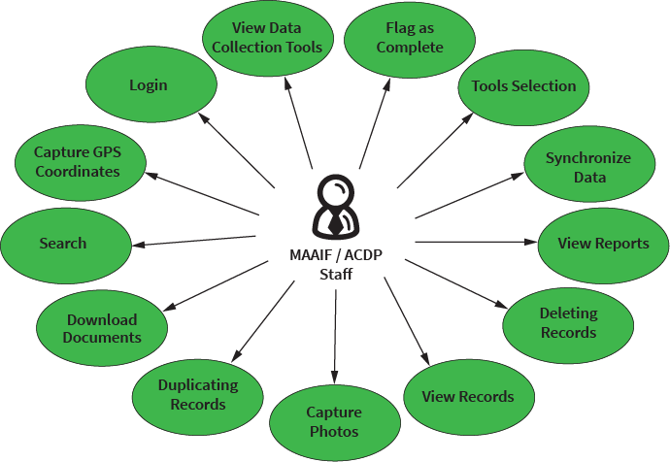

**Figure 7.1:** **The MAAIF/ACDP Use Cases**

The different Use Case diagrams and descriptions are detailed in sections 7.1 to 7.16.

## 7.1 User Login

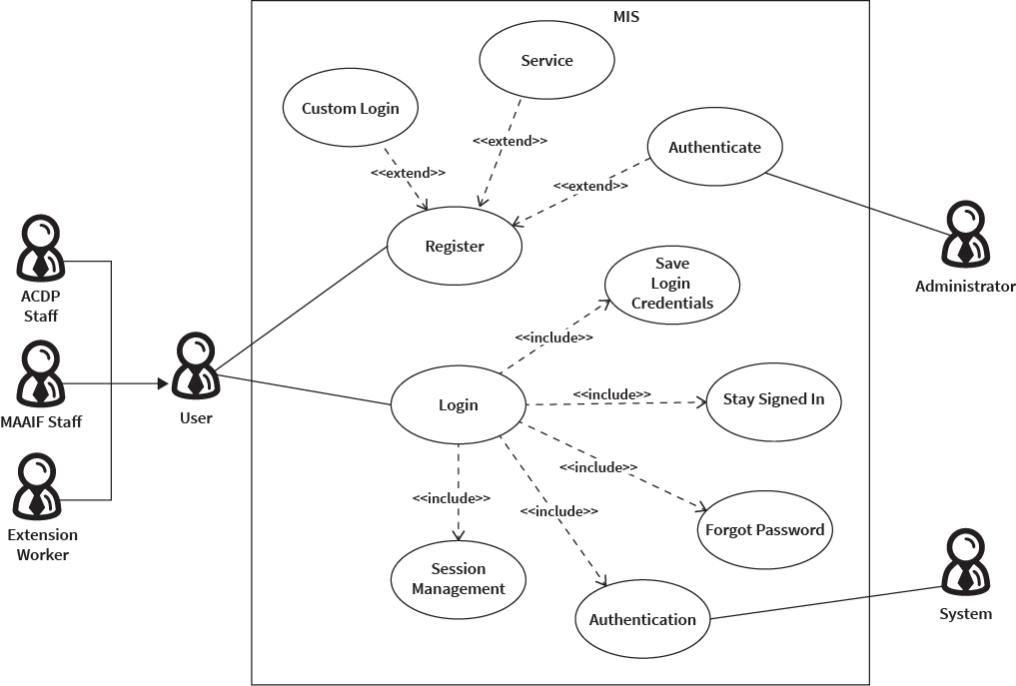

**Figure 7.2: User Login Use Case diagram**

**Table 7.1:** **User Login Use Case description**

|  |  |
| --- | --- |
| **Use Case ID:** | US-001 |
| **Use Case Name:** | User Login |
| **Summary:** | This use case lets the user login to the MIS in-order for the system to determine appropriate access level. |
| **Primary Actor** | MAAIF / ACDP staff |
| **Basic Flow:** | 1. The use case starts when a user indicates that he wants to login. 2. The user runs the application 3. View the Log-In Page 4. The system requests for the username and password. 5. The user enters his/her username and password. 6. The system verifies the username and password against all registered users. 7. The system starts a login session and displays a welcome message based on the user's preferences. |
| **Alternative Flows:** | Step 6:  If username is invalid, the use case goes back to step 5.  Step 6:  If the password is invalid the system requests that the user re-enter the password. When the user enters the correct password use case continues with step 6. |
| **Categorization:** | 1. Volatility: Low 2. Frequency: High 3. Criticality: High 4. Probability of Defects: Medium 5. Risk: Medium |
| **Pre-conditions:** | The user is registered. |
| **Post-conditions:** | The user can now obtain data and perform functions according to his registered access level. |
| **Business Rules:** | Some data and functions are restricted to certain types of users or users with a particular access level. |

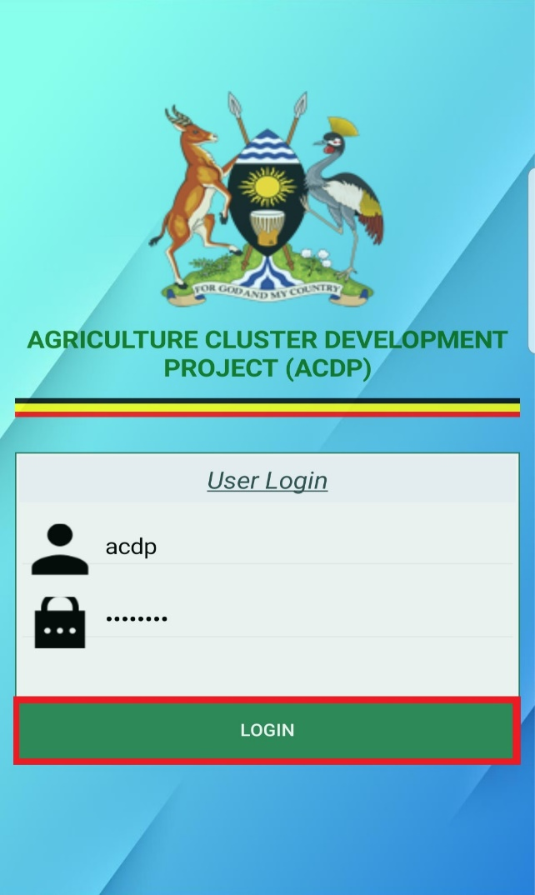

**Figure 0.1: User Login implementation**

## 7.2 Data capture tools download

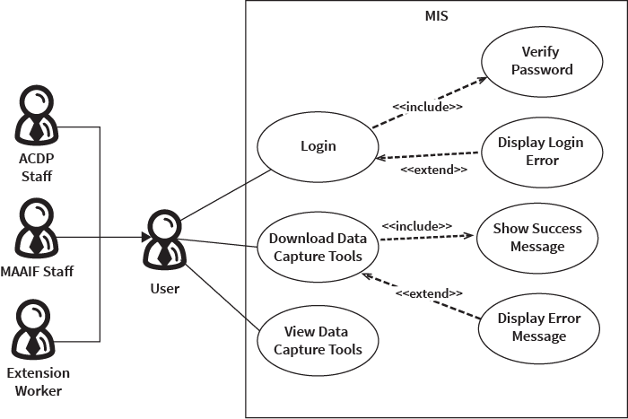

**Figure 7.3: Data Capture Tools (pull from server) use case diagram**

**Table 7.2:Data capture tools selection Use Case description**

|  |  |
| --- | --- |
| **Use Case ID:** | US-002 |
| **Use Case Name:** | Data Capture tools download |
| **Summary:** | This use case lets the user download the updated data capture tools and lookup tables to be used during data collection. |
| **Primary Actor** | MAAIF / ACDP staff |
| **Basic Flow:** | 1. The use case starts when a Data Entrant wants to enter data 2. The user selects synchronize from the home page of the application. 3. The user download all updated data capture forms and lookup values published onto the web-based MIS. 4. The user views all the current data capture tools. |
| **Alternative Flows:** | Step 3:  If data capture tools are not available the MIS displays an error and goes back to step 2. |
| **Categorization:** | 1. Volatility Low  2. Frequency: Medium  3. Criticality: High  4. Probability of Defects: Medium  5. Risk: Low |
| **Pre-conditions:** | The user is logged onto the application on a device connected to the internet. |
| **Post-conditions:** | The user can now capture the necessary data |
| **Business Rules:** | Tool selection allowed are those defined in the application. |

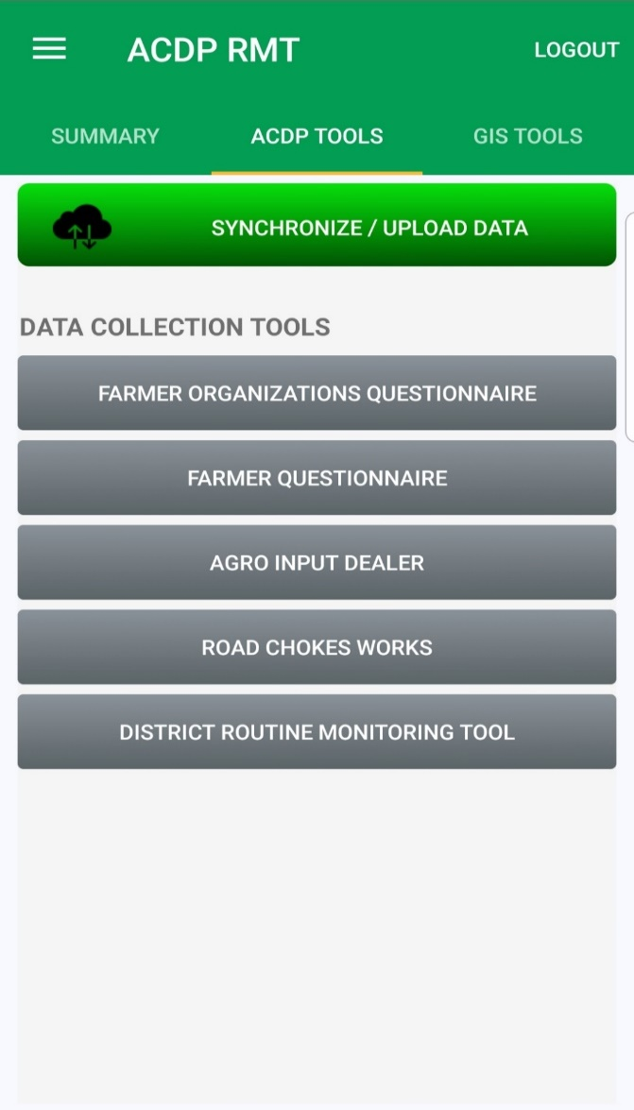

**Figure 0.2: Data Capture Tools (pull from server) implementation**

## 7.3 Survey Data capture

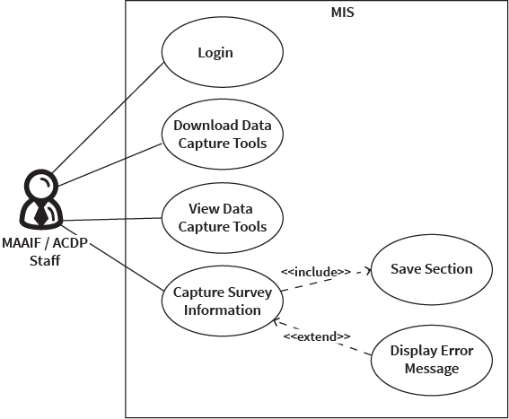

**Figure 7.4: Survey Data capture Use Case diagram**

**Table 7.3: Survey Data capture Use Case description**

|  |  |
| --- | --- |
| **Use Case ID:** | US-003 |
| **Use Case Name:** | Survey Data Capture |
| **Summary:** | This use case allows the user capture survey data using particular selected data capture tool. |
| **Primary Actor** | MAAIF / ACDP staff |
| **Basic Flow:** | 1. The use case starts when a Data Entrant wants to capture survey data 2. The system displays all current data capture tools. 3. The user selects the appropriate data capture tool. 4. The user captures the intended survey data on the data collection form 5. The user views the captured information to verify its completeness. User can move to a previous page in the application by tapping the back arrow in the application to update any required field. 6. The user can save partial captured data and continue to complete the form later 7. On completion of the survey data capture, a user flags the form as complete at the captured record details page 8. Data of a completed form is then saved in the system |
| **Alternative Flows:** | Step 7:   1. If a user flags a form as complete when it’s not an error is displayed 2. User is able to view the validation errors on a form by tapping the show validation errors button on the captured record details page and goes back to 5 |
| **Categorization:** | 1. Volatility: Medium  2. Frequency: High  3. Criticality: High  4. Probability of Defects: Medium  5. Risk: Low |
| **Preconditions:** | The user is logged onto the application and able to view the different data capture tools available for entry |
| **Post-conditions:** | The system has available information for the instance(s) when the form is flagged as completed. |
| **Business Rules:** | Tool selection allowed are those defined in the application. |

|  |  |
| --- | --- |
| **Figure 0.3: Survey Data capture implementation** |  |

## 7.4 GPS coordinates data capture

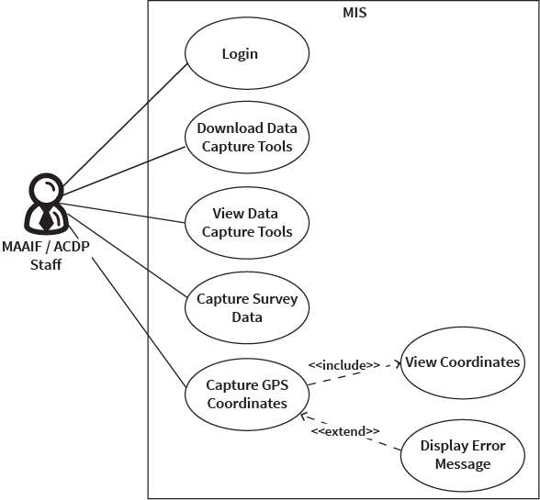

**Figure 7.5: GPS coordinates data capture Use Case diagram**

**Table 7.4: GPS coordinates data capture Use Case description**

|  |  |
| --- | --- |
| **Use Case ID:** | US-004 |
| **Use Case Name:** | GPS Coordinates data capture |
| **Summary:** | This use case allows the user capture GPS coordinates and/or altitude data of the area they are conducting their interviews by tapping the “update” button on the GPS coordinates page. |
| **Primary Actor** | MAAIF / ACDP staff |
| **Basic Flow:** | 1. The use case starts when a Data Entrant wants to capture GPS coordinates and/or altitude data 2. The system displays all current data capture tools. 3. The user selects GPS coordinates page. 4. The user captures the GPS coordinates and/or altitude of the interview area 5. The user views the captured information to verify its completeness and accuracy. 6. On completion of the data capture, a user flags the form as complete at the captured record details page 7. Completed and accurate GPS Coordinates and/or altitude of the survey area captured is then saved in the system 8. Recapture of the GPS Coordinates and/or altitude can be done when the information captured is not accurate. |
| **Alternative Flows:** | Step 7:   1. User is able to view the validation errors on a page 2. If the GPS Coordinates and/or altitude of the survey area is not accurate then go to 8. |
| **Categorization:** | 1. Volatility: Medium  2. Frequency: High  3. Criticality: High  4. Probability of Defects: Medium  5. Risk: Low |
| **Pre-conditions:** | The user is logged onto the application and GPS coordinates page is available. They must have enabled the application to access the device’s location. |
| **Post-conditions:** | The system has available information for the instance(s) when the update button is tapped. |
| **Business Rules:** | A complete survey data should include correct GPS coordinate and/or altitude of the area where the survey is being conducted... |

|  |  |
| --- | --- |
| **Figure 0.4: GPS coordinates data capture implementation** |  |

## 7.5 Photo capture

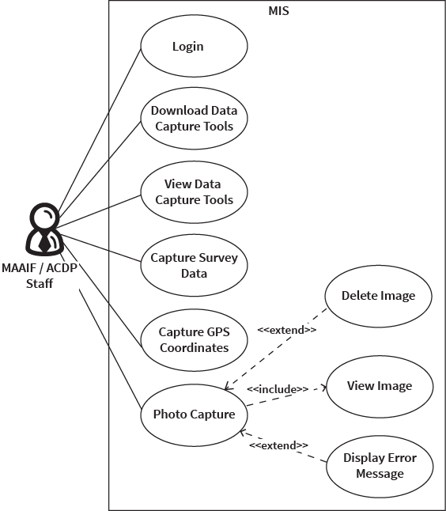

**Figure 7.6: Photo capture Use Case diagram**

**Table 7.5: Photo capture Use Case description**

|  |  |
| --- | --- |
| **Use Case ID:** | US-005 |
| **Use Case Name:** | Photo capture |
| **Summary:** | This use case allows the user take photos of the area they are conducting their interviews by tapping the “take picture” button on the photo page. |
| **Primary Actor** | MAAIF/ACDP staff |
| **Basic Flow:** | 1. The use case starts when a Data Entrant wants to take pictures 2. The user must be able to grant or deny the application access to the photos, media and files on their device in order for it to take photos. 3. The application displays the “take picture” button on the photo page. 4. The user taps the “take picture” button on the photo page in-order to take a photo. |
| **Alternative Flows:** | Step 4:   1. User must be able to delete a photo if deemed unsatisfactory by tapping the “delete picture” button on the photo page. |
| **Categorization:** | 1. Volatility: Medium  2. Frequency: High  3. Criticality: High  4. Probability of Defects: Medium  5. Risk: Low |
| **Preconditions:** | The user has enabled the application to access the device’s camera, photos, media and files. |
| **Post conditions:** | The system has available information for the instance(s) when the “take picture” button on the photo page is tapped. |
| **Business Rules:** | A complete survey data should include photos of the area where the survey is being conducted. |

|  |  |
| --- | --- |
| **Figure 0.5: Photo capture implementation** |  |

## 7.6 Record Management

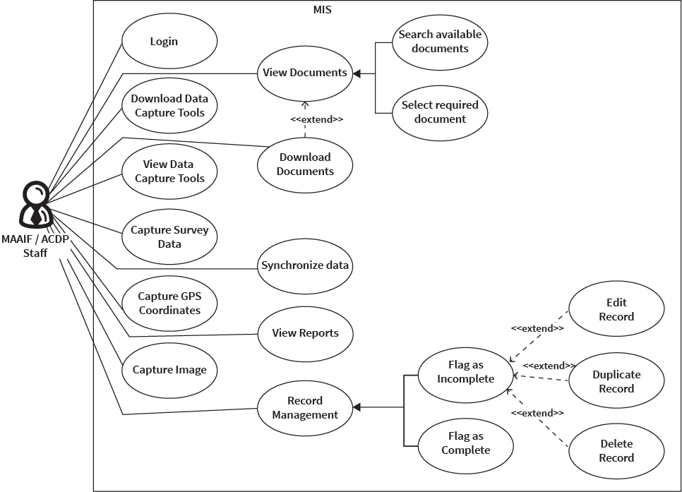

**Figure 7.7: Record Management Use Case**

**Table 7.6: Record Management Use Case description**

|  |  |
| --- | --- |
| **Use Case ID:** | US-006 |
| **Use Case Name:** | Record Management |
| **Summary:** | This use case enables the users to manage the data captured before it is uploaded onto the MIS database. |
| **Primary Actor** | MAAIF / ACDP staff |
| **Basic Flow:** | 1. The use case starts when a User has completed data capture and wants to manage the data on their device. 2. The user selects “flag as incomplete” button in order to be granted access to editing the data in an already completed form. 3. The user selects edit record in order to edit data in a completed form. 4. After editing the necessary information, the user can then select save record in order to save changes made to the form. 5. The user selects the “flag as complete” button at the centre of the screen if he requires to send the record to the ACDP MIS database after synchronization. |
| **Alternative Flows:** | Step 4:   1. If the data synchronization is not successful, go back to 4. |
| **Categorization:** | 1. Volatility: Medium  2. Frequency: High  3. Criticality: High  4. Probability of Defects: Medium  5. Risk: Low |
| **Pre-conditions:** | The user has entered data into the mobile data capture tools. |
| **Post-conditions:** | Records flagged as complete can then be synchronized to the MIS database. |
| **Business Rules:** | Only records that are flagged as complete can be synchronized. By default, all records are incomplete unless flagged as complete. |

|  |  |
| --- | --- |
| **Figure 0.6: Record Management implementation** |  |

## 7.7 Data Synchronization

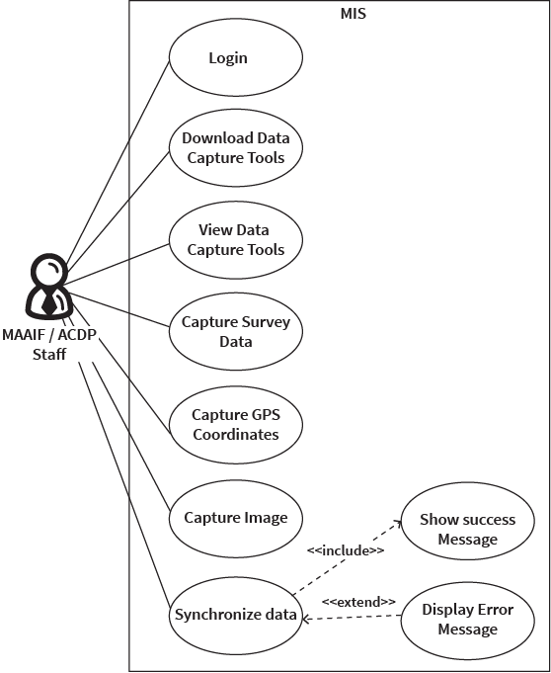

**Figure 7.8: Synchronize data (push to server) Use Case diagram**

**Table 7.7:** Data Synchronization Use Case Description

|  |  |
| --- | --- |
| **Use Case ID:** | US-007 |
| **Use Case Name:** | Data Synchronization |
| **Summary:** | This use case enables completed data captured to be sent to the online MIS |
| **Primary Actor** | MAAIF / ACDP staff |
| **Basic Flow:** | 1. The use case starts when a Data Entrant has completed data capture and wants to send the data to the MIS database. 2. The user saves the form. 3. The user hits the synchronize button at the centre on the home screen 4. If the data synchronization is successful, a success message is displayed. |
| **Alternative Flows:** | Step 4:   1. If the data synchronization is not successful, go back to step 3. |
| **Categorization:** | 1. Volatility: Medium  2. Frequency: High  3. Criticality: High  4. Probability of Defects: Medium  5. Risk: Low |
| **Pre-conditions:** | The user has flagged the records for upload as complete. The user also needs a working internet connection in order to synchronize data. |
| **Post-conditions:** | Captured records are uploaded to the online MIS |
| **Business Rules:** | Data synchronization function is available to all MIS users with data entry rights. |

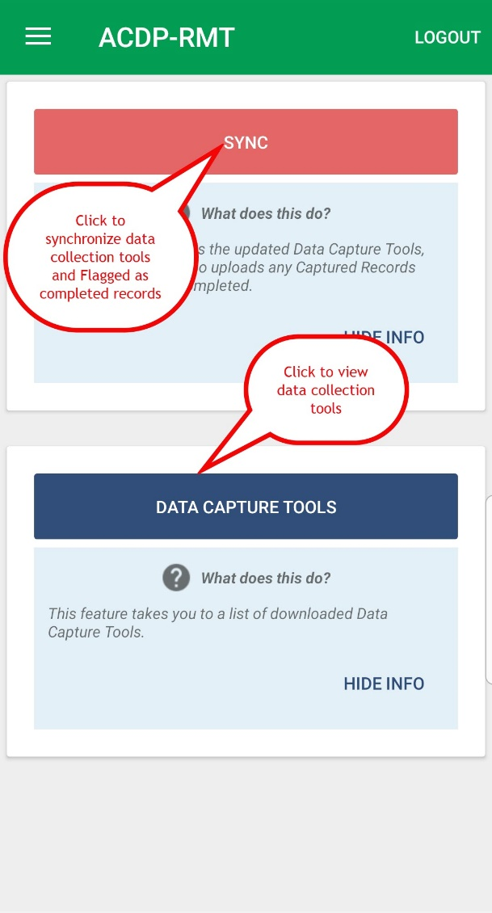

**Figure 0.7: Data Synchronization implementation**

## 7.8 View and download documents

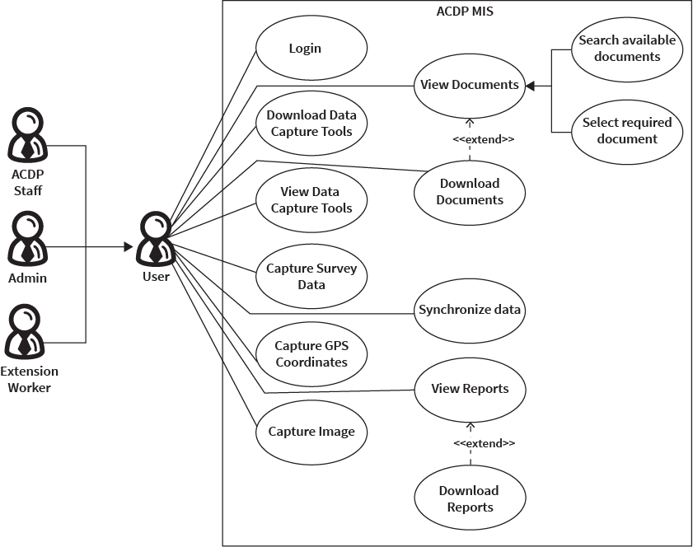

**Figure 7.9: View and Download Documents Use Case diagram**

**Table 7.8: View and download documents Use Case description**

|  |  |
| --- | --- |
| **Use Case ID:** | US-008 |
| **Use Case Name:** | View and Download Documents |
| **Summary:** | This use case allows the user view and download documents from the MIS. |
| **Primary Actor** | MAAIF / ACDP staff |
| **Basic Flow:** | 1. The use case starts when a user wants to view or download data from the ACDP MIS.The system displays all current data capture tools. 2. The user selects view/download documents from the overhead menu 3. The user selects the document/file they would like to view/download 4. The document/file is viewed or downloaded. |
| **Alternative Flows:** |  |
| **Categorization:** | 1. Volatility: Medium  2. Frequency: High  3. Criticality: High  4. Probability of Defects: Medium  5. Risk: Low |
| **Preconditions:** | The user is logged on to the ACDP MIS online platform. |
| **Post conditions:** | The document/file is downloaded and available for use outside the ACDP MIS or viewed. |
| **Business Rules:** | The system allows document/file to be downloaded as CSV, PDF,……. |

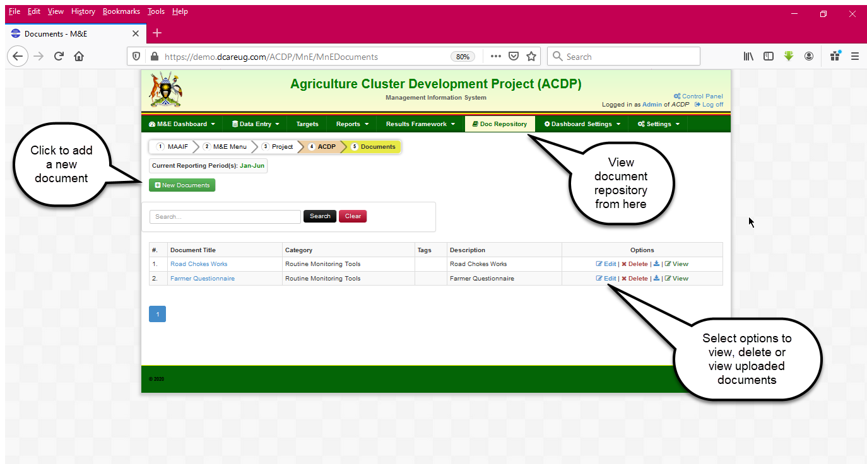

**Figure 0.8: View and download documents implementation**

**The MIS Administrator**

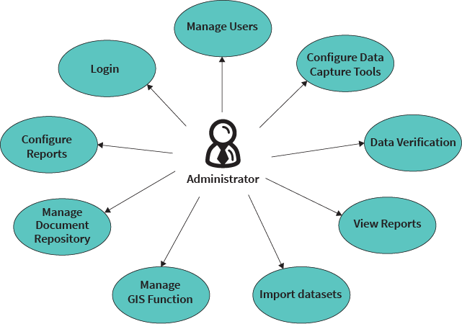

**Figure 7.10: The Administrator Use Cases**

## 7.9 Administrator Login

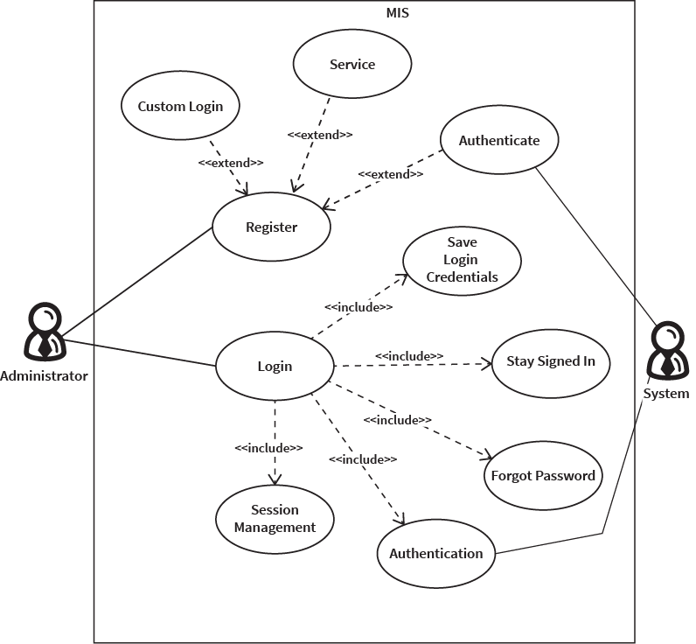

**Figure 7.11: Administrator Login Use Case diagram**

**Table 7.9: Administrator Login Use Case description**

|  |  |
| --- | --- |
| **Use Case ID:** | US-009 |
| **Use Case Name:** | Administrator Login |
| **Summary:** | This use case lets the administrator login to the ACDP MIS to perform administrative roles. |
| **Primary Actor** | Administrator |
| **Basic Flow:** | 1. The use case starts when the administrator indicates that he/she wants to login. 2. The administrator runs the application 3. View the Log-In Page 4. The system requests for the username and password. 5. The administrator enters his/her username and password. 6. The system verifies the username and password against all registered users. 7. The administrative dashboard is availed to the Administrator 8. The administrator performs the required administrative tasks 9. The administrator logs out |
| **Alternative Flows:** | Step 6:  if username is invalid, the use case goes back to step 5.  Step 6:  if the password is invalid the system requests that the user re-enter the password. When the administrator enters the correct password the use case continues with step 6. |
| **Categorization:** | 1. Volatility: Low 2. Frequency: Medium 3. Criticality: High 4. Probability of Defects: Low 5. Risk: High |
| **Pre-conditions:** | The administrator is registered. |
| **Post-conditions:** | The administrator has performed the administrative roles and respective users are able to use the MIS as per their defined profiles. |
| **Business Rules:** | Users are assigned profiles as dictated by MAAIF and ACDP management guidelines. |

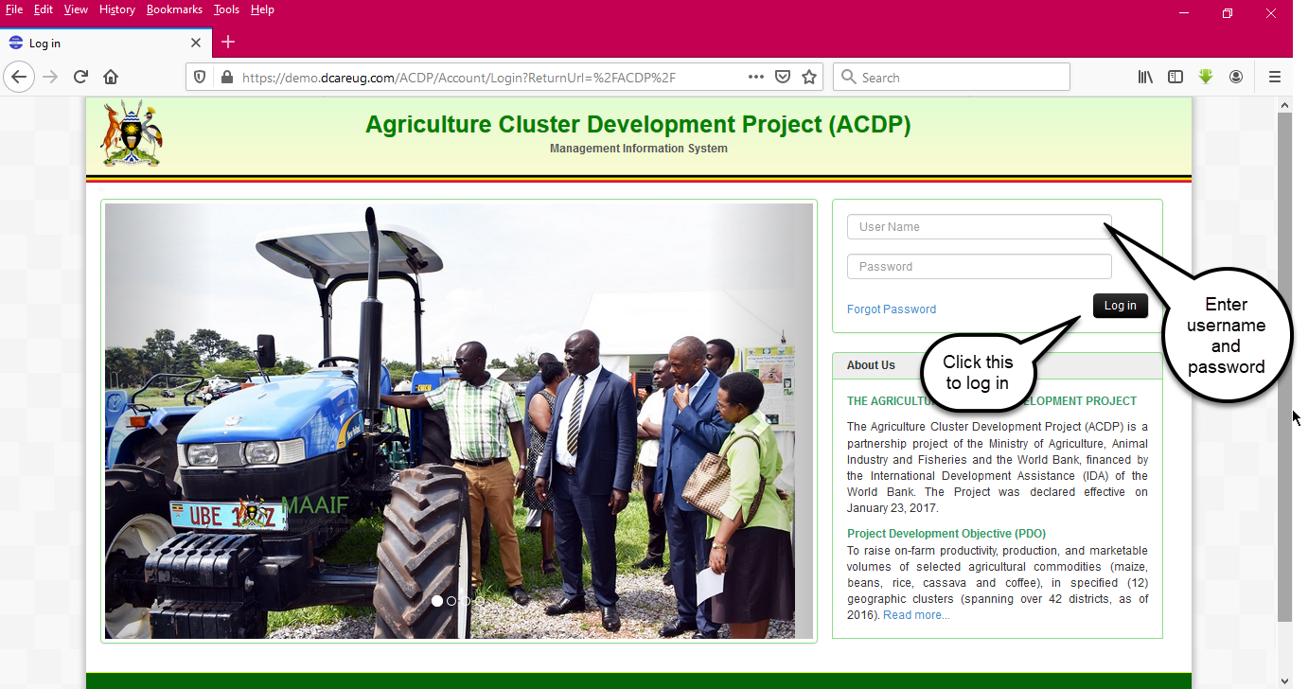

**Figure 0.9: Administrator Login implementation**

## 7.10 Configure data collection tools

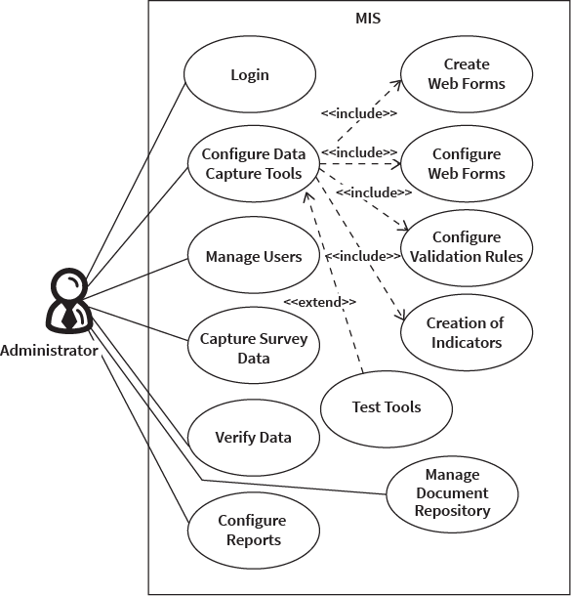

**Figure 7.12: Configure Data Capture Tools Use Case diagram**

**Table 7.10: Configure data collection tools Use Case description**

|  |  |
| --- | --- |
| **Use Case ID:** | US-010 |
| **Use Case Name:** | Configure Data Collection Tools |
| **Summary:** | This use case allows the Administrator to configure data collection tools in the MIS. |
| **Primary Actor** | Administrator |
| **Basic Flow:** | 1. The use case starts when the administrator wants to configure a data collection tools. 2. The Administrator then selects the web form to be configured 3. The Administrator configures the validation rules 4. The Administrator configures the data capture tools 5. The document clicks on the save button to save the configurations. |
| **Alternative Flows:** | Step 1:   1. Administrator must be able to create a new form that can be configured as required. |
| **Categorization:** | 1. Volatility: Low  2. Frequency: Low  3. Criticality: High  4. Probability of Defects: Low  5. Risk: Low |
| **Pre-conditions:** | The Administrator is logged on to the back end of the MIS. |
| **Post-conditions:** | Data collection tools are available in MIS |
| **Business Rules:** | The Administrator has the sole authority to configure data collection tools for use during surveys |

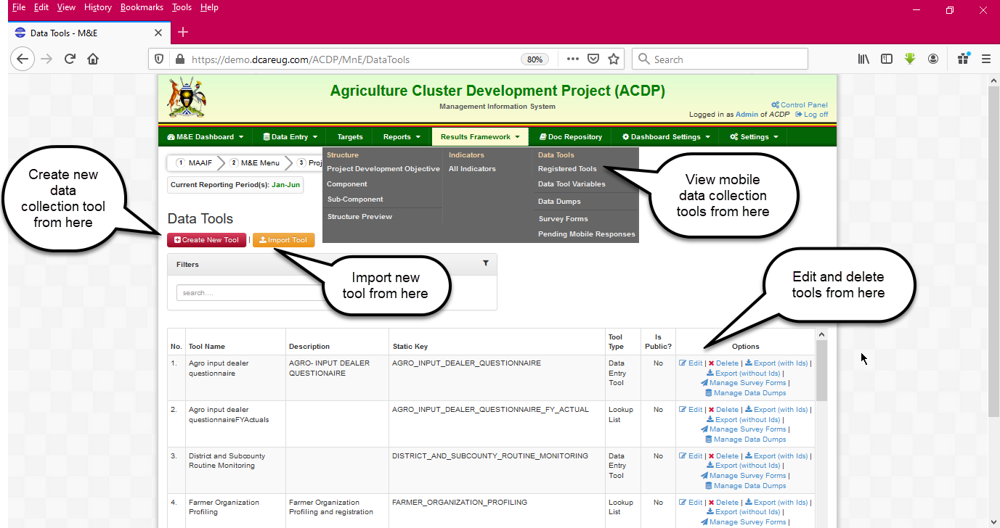

**Figure 0.10: Configure data collection tools implementation**

## 7.11 User Management

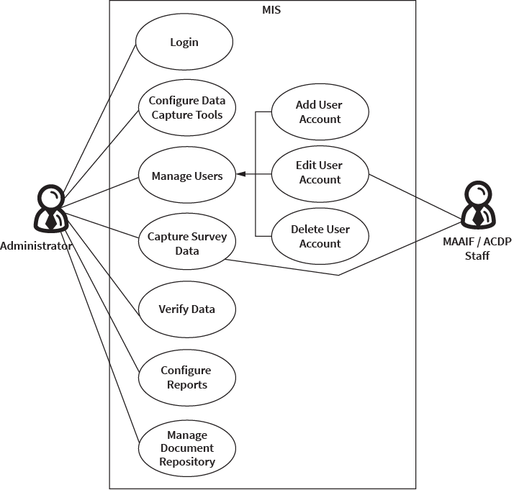

**Figure 7.13: User management Use Case diagram**

**Table 7.11: User management Use Case description**

|  |  |
| --- | --- |
| **Use Case ID:** | US-011 |
| **Use Case Name:** | User and Group Management |
| **Summary:** | This use case allows the Administrator to manage users and groups in the MIS. |
| **Primary Actor** | Administrator |
| **Basic Flow:** | 1. The use case starts when the Administrator wants to manage a user or group. 2. The administrator accesses the administrative dashboard 3. The administrator creates a user / group if non-existent. 4. The administrator selects user / group. 5. The administrator grants roles as may be required. 6. The user roles are updated in the MIS database. |
| **Alternative Flows:** | Step 3   1. If the creation is not successful then go back to step 3. 2. If a user / group profile changes, then go back to step 4.   Step 5   1. If the administrator desires to delete a user from the server, he /she selects delete from the overhead menu. 2. The administrator confirms the delete request by selecting yes from the pop-up menu. |
| **Categorization:** | 1. Volatility: Low  2. Frequency: Low  3. Criticality: High  4. Probability of Defects: Medium  5. Risk: High |
| **Pre-conditions:** | The Administrator is logged on to the back end of the MIS. |
| **Post-conditions:** | Users and group are created in the MIS database. |
| **Business Rules:** | The Administrator has the sole authority to configure data collection tools for use during surveys |

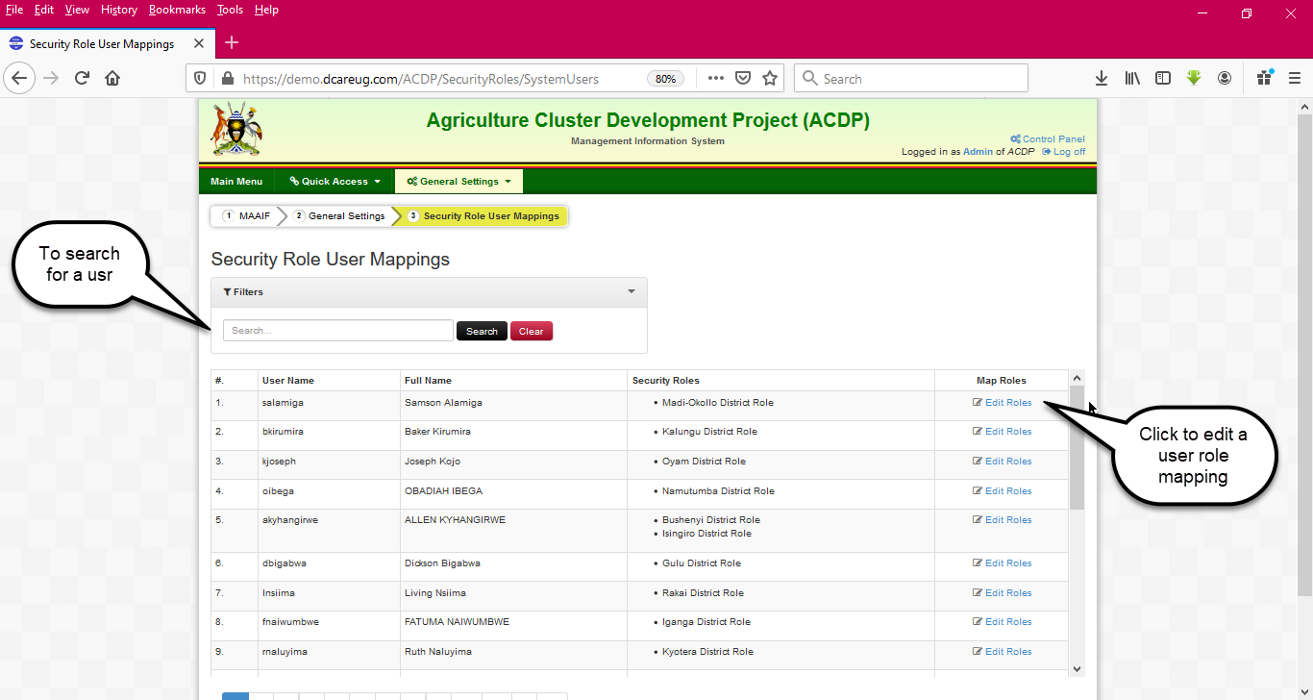

**Figure 0.11: User management implementation**

## 7.12 Verify Data

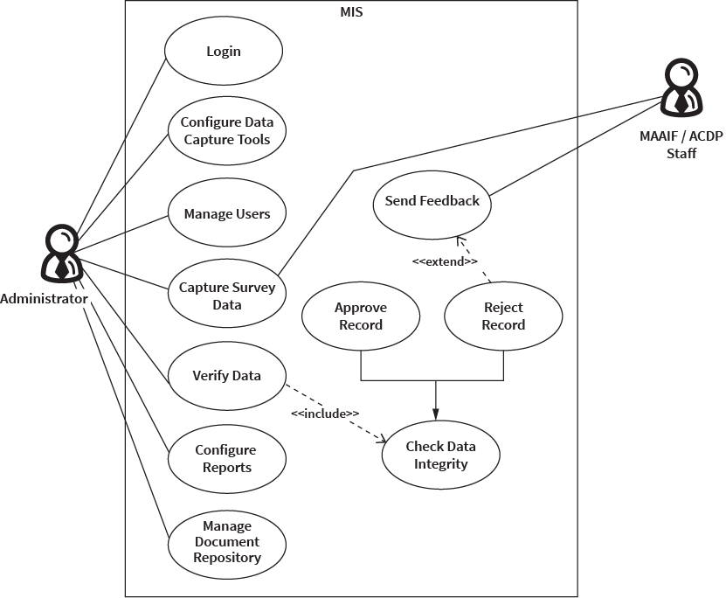

**Figure 7.14:** **Verify Data Use Case diagram**

**Table 7.12: Verify Data Use Case description**

|  |  |
| --- | --- |
| **Use Case ID:** | US-012 |
| **Use Case Name:** | Data Verification |
| **Summary:** | This use case allows the Administrator to check the integrity of data submitted by users collecting data. |
| **Primary Actor** | Administrator |
| **Basic Flow:** | 1. The use case starts when the user submits data to the online MIS 2. The administrator accesses the administrative dashboard 3. The administrator views records that have been pushed to the server to check for errors in entry. 4. If the data passes the integrity check, the administrator approves the records 5. The administrator saves the records to the MIS database. |
| **Alternative Flows:** | Step 3   1. If the data fails the integrity check, the administrator rejects the record. 2. The administrator saves a reason for the rejection. 3. The record is sent back to the data entrant for their action. |
| **Categorization:** | 1. Volatility: Low  2. Frequency: Medium  3. Criticality: High  4. Probability of Defects: Medium  5. Risk: Medium |
| **Pre-conditions:** | The Administrator is logged on to the back end of the MIS. |
| **Post-conditions:** | Data collected is saved onto the MIS |
| **Business Rules:** | The Administrator has the authority to accept or reject records submitted to the MIS by data entrants. |

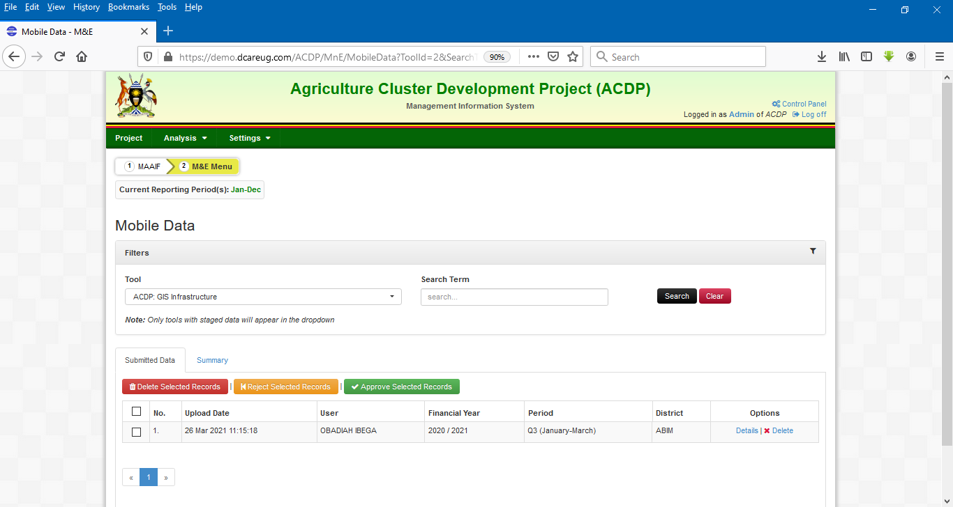

**Figure 0.12: Verify Data implementation**

## 7.13 Configure reports

## 

**Figure 7.15:** **Configure Reports Use Case diagram**

**Table 7.13: Configure reports Use Case Description**

|  |  |
| --- | --- |
| **Use Case ID:** | US-011 |
| **Use Case Name:** | Configure Reports |
| **Summary:** | This use case allows the Administrator to configure reports in the ACDP MIS. |
| **Primary Actor** | Administrator |
| **Basic Flow:** | 1. The use case starts when the administrator wants to configure reports. 2. The Administrator logs on the dashboard 3. Configures the queries & parameters, report output format and indicators. 4. Validates the integrity of the data 5. Provides access rights to users depending on which reports they will need to access. 6. Reports available on the portal |
| **Alternative Flows:** | Step 6:  If report not available go back to step 3. |
| **Categorization:** | 1. Volatility: Low  2. Frequency: Medium  3. Criticality: High  4. Probability of Defects: Medium  5. Risk: Low |
| **Pre-conditions:** | The Administrator is logged onto the Administrator dashboard. |
| **Post-conditions:** | Reports are available in ACDP MIS |
| **Business Rules:** | The Administrator has the sole authority to configure the queries & parameters, report output format and indicators as well give access rights to users. |

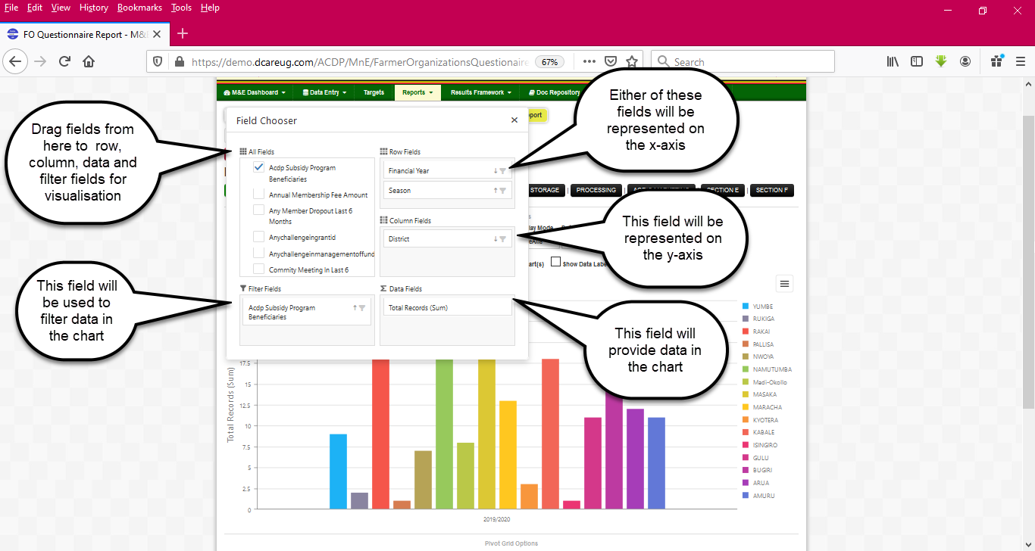

**Figure 0.13: Configure Reports implementation**

## 7.14 Manage Document Repository

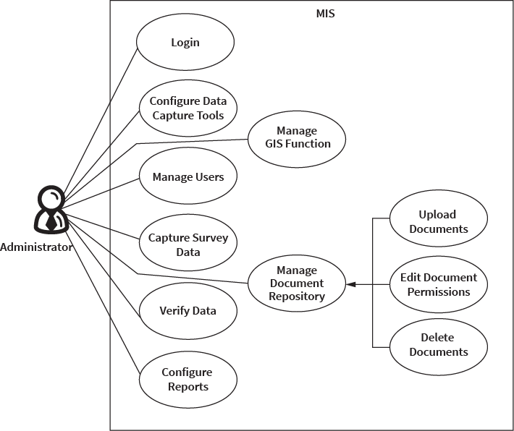

**Figure 7.16:** **Manage Document Repository Use Case diagram**

**Table 7.14: Manage Document Repository Use Case description**

|  |  |
| --- | --- |
| **Use Case ID:** | US-013 |
| **Use Case Name:** | Manage Document Repository |
| **Summary:** | This use case allows the Administrator to Manage the document repository on the MIS. |
| **Primary Actor** | Administrator |
| **Basic Flow:** | 1. The use case starts when the administrator wants to manage documents on the MIS online repository 2. The administrator accesses the administrative dashboard 3. The administrator selects the document to upload. 4. The administrator uploads the document onto the MIS. 5. The administrator selects the document 6. The administrator assigns a user / user group to the document 7. The administrator edits the document permissions in accordance to the user / user group assigned. 8. The administrator saves the changes made. |
| **Alternative Flows:** | Step 3   1. If the document to be edited is already existing on the server, skip to step 5   Step 6   1. If the administrator desires to delete a document from the server, he / she selects delete from the overhead menu. 2. The administrator confirms the delete request by selecting yes from the pop-up menu. |
| **Categorization:** | 1. Volatility: Low  2. Frequency: Medium  3. Criticality: Medium  4. Probability of Defects: Low  5. Risk: Medium |
| **Pre-conditions:** | The Administrator is logged on to the back end of the MIS. |
| **Post-conditions:** | Data collected is saved onto the MIS |
| **Business Rules:** | The Administrator has the sole authority to upload documents onto the MIS and assign the documents to the user/ user groups. |

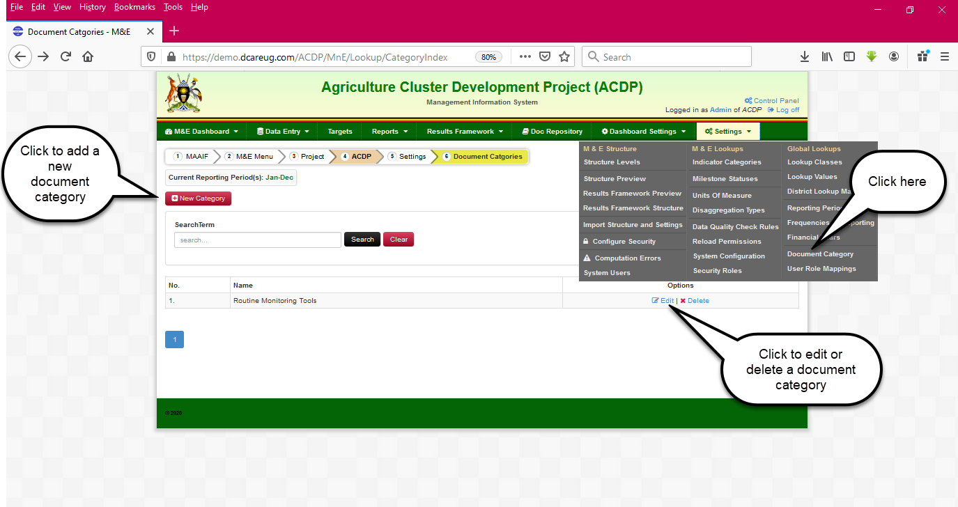

**Figure 0.14: Manage Document Repository implementation**

## 7.15 Manage GIS

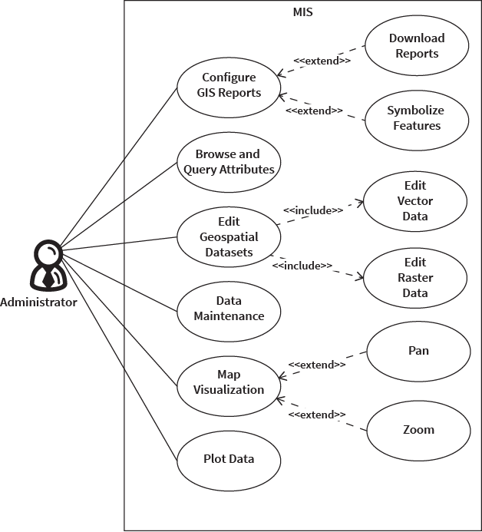

**Figure 7.17:** **Manage GIS Function Use Case diagram**

**Table 7.15: Manage GIS Function Use Case description**

|  |  |
| --- | --- |
| **Use Case ID:** | US-015 |
| **Use Case Name:** | Manage GIS Function |
| **Summary:** | This use case allows the Administrator to Manage the GIS functions of the MIS. |
| **Primary Actor** | Administrator |
| **Basic Flow:** | 1. The use case starts when the administrator wants to manage the GIS functions on the MIS. 2. The administrator accesses the administrative dashboard 3. The administrator then selects the data tab on the overhead menu. 4. The administrator can now search the attribute data that he/she requires to view. 5. The administrator makes the required edits to the selected attribute 6. The administrator saves the attribute. |
| **Alternative Flows:** | Step 4   1. If the administrator requires to view maps he/she accesses map service from the overhead menu 2. The administrator then browses the map to locate required information using the pan and zoom functions. |
| **Categorization:** | 1. Volatility: Low  2. Frequency: Medium  3. Criticality: Medium  4. Probability of Defects: Low  5. Risk: Medium |
| **Pre-conditions:** | The Administrator is logged on to the back end of the MIS. |
| **Post-conditions:** | Geospatial Data collected is managed within the MIS |
| **Business Rules:** | The Administrator has the sole authority to upload documents onto the MIS and assign the documents to the user/ user groups. |

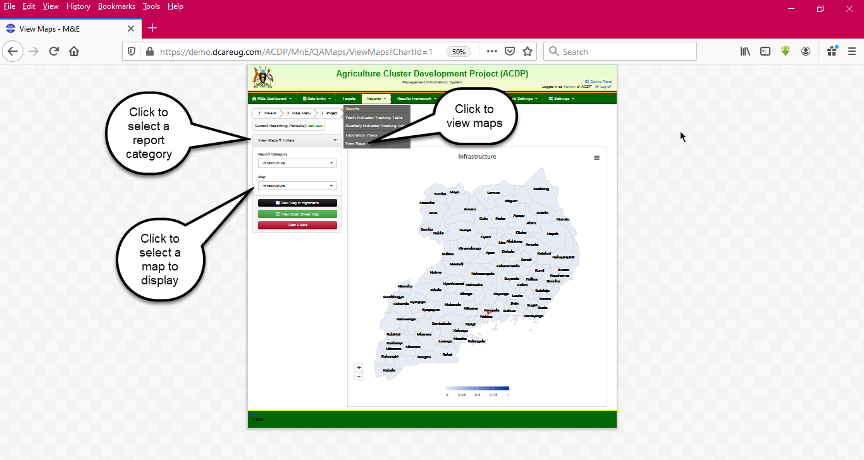

**Figure 0.15: Manage GIS implementation**

## 7.16 Interoperability

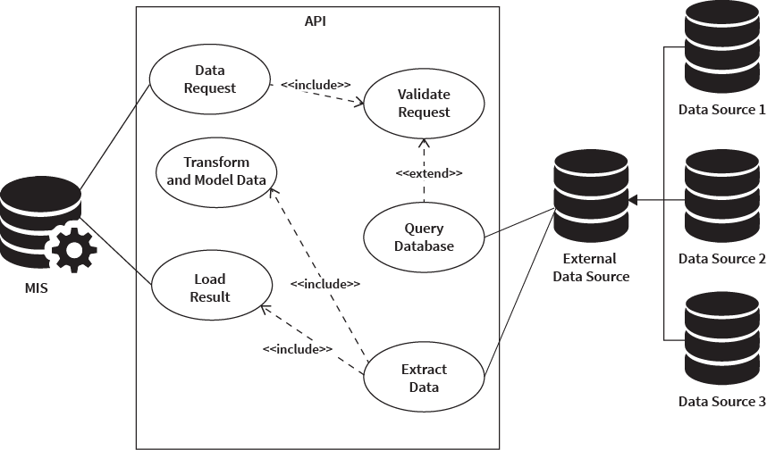

**Figure 7.18:** **Interoperability Use Case**

**Table 7.16: Interoperability Use Case description**

|  |  |
| --- | --- |
| **Use Case ID:** | US-016 |
| **Use Case Name:** | Interoperability |
| **Summary:** | This use case enables the MIS to import data from external systems. |
| **Primary Actor** | The MIS |
| **Basic Flow:** | 1. The use case starts when a the MIS wants to import data from the external system. 2. The MIS requests for a dataset from the API 3. The API queries the external MIS for the required variables 4. The external MIS validates the request 5. The external MIS sends the requested data to the API 6. The API transforms the data into the expected format 7. The API loads the data to the MIS. |
| **Alternative Flows:** | Step 4:   1. If the request does not match, then an exception error is thrown. 2. Go back to step 2. |
| **Categorization:** | 1. Volatility: Medium  2. Frequency: High  3. Criticality: High  4. Probability of Defects: Medium  5. Risk: Low |
| **Pre-conditions:** | The external system must have an API exposed to the MIS. |
| **Post-conditions:** | Requested data from the external system is loaded into the MIS. |
| **Business Rules:** | The API should be configured to allow exchange of required data between systems. |

**Annex I: Technical Requirements Specifications**

**Technical Requirements**

|  |
| --- |
| **THE REPUBLIC OF UGANDA** |

**MINISTRY OF AGRICULTURE, ANIMAL INDUSTRY AND FISHERIES**

**~~~~~~~~~~~~~~~~~~**

**AGRICULTURE CLUSTER DEVELOPMENT PROJECT (ACDP)**

THE DISRUPTIVE AGRICULTURAL TECHNOLOGY INNOVATION CHALLENGE

**Supply and Installation of a Performance Monitoring and Evaluation Solution for Data Analytics**

**June, 2020**

**1.0 Background**

The Government of Uganda (GOU), through the Ministry of Agriculture, Animal Industry and Fisheries (MAAIF) received funding from the World Bank towards the cost of the Agriculture Cluster Development Project (ACDP). The project objective is to raise on-farm production, productivity, and marketable volumes of **Beans, Rice, Maize, Cassava** and **Coffee**, in 12 geographical clusters, making up 55 districts. ACDP is uniquely designed to leverage digital and disruptive Agricultural Technologies, delivering agricultural services to farmers including; input subsidies, extension, market information, and others through innovations such as e-vouchers, e-wallet, e-extension, e-diary, e-statistics, and Management Information Systems (MIS).

The project has met various challenges in the implementation such as: delays in the development of the applications and system failures which has affected farmer group registration, farmer enrolments, farmer access to project information and agricultural extension, project implementation and monitoring, and data analytics. These challenges have slowed the progress of the project towards the realisation of the development objective. It is envisioned that interventions such as **Disruptive Agricultural Technological** **(DAT)[1]** Innovation Challenge, could help MAAIF and project team to identify technological applications to turn around the project performance, through automation of key business processes along the value chain, as well as improving service delivery to the intended project beneficiaries.

Accordingly, MAAIF in partnership with the World Bank organised a **DAT Innovation challenge**, in which agri-tech firms with proven agricultural digital solutions were invited to express interest in showcasing their innovative solutions that could mitigate implementation challenges of the ACDP. The objective of the Innovation Challenge was to explore opportunities offered by Disruptive Agricultural Technologies (DATs) to address the ACDP implementation challenges. Implementational challenges were categorised into four major categories, namely; (1) Advisory and Information for agricultural productivity, (2) Market Linkages, (3) Financial Inclusion, and (4) Data Analytics. Each of the categories was further subdivided into the specific challenge areas, to obtain functional specific solutions. **(See *Annex 1*)**.

An invitation to express interest was run in the print media, and other platforms on October 07, 2019, and over Eighty-Eight applications were received, out of which 22 met the selection criteria as defined. The Twenty-Two successful applicants were mentored by the ministry technical staff through a one-day boot camp, to give them a chance to understand the requirement at hand, and to modify their application to meet the solutions requirements. These were subjected to another vetting process through which 15 candidates were identified to pitch their solutions. Only one solution was required per challenge area, and by the end of the pitch day, a winner had been identified from each of the challenge area. Two solutions were also identified for uptake because they presented a unique approach to solving some of the major challenges of the project. These included Jabba Engineering Limited, that offered a mobile soil analysis solution and Converge Systems Limited that offered a farmer profiling solution. The six candidates were invited to a proof-of-concept workshop, as the final stage of engagement before the solutions uptake.

**2.0** **Objective of the requirement**

The main objective of the requirement is to enhance the functionality of the existing solution as presented at the proof-of-concept workshop, by bridging the identified gaps to offer an all-inclusive Performance Monitoring and Evaluation System, to facilitate delivery of the project

**2.1 Specific Objectives**

Specifically, the firm will be required to;

1. To enhance the System to address the gaps identified at the proof of concept workshop, highlighted under scope of assignment in this document, and present a comprehensive application;
2. To provide user training and requisite operational manuals for the system;
3. Provide technical support and maintenance of the platform for a specified period of time as highlighted under the list of deliverables

**3.0 Scope of Work**

The firm shall be required to present a complete current system functionality, and additionally address the gaps identified under areas for enhancement as indicated below;

* Develop an effective, efficient, expandable and interoperable MIS that integrates and is compatible with existing systems in the project
* Ensure that the MIS is capable of providing quick analysis (dashboard capability) of trends and comparisons against defined indicators at various levels.
* Develop mechanism for ensuring effective internal coordination within the project functions such as planning, finance, administration, procurement, M&E
* Develop an Agricultural Water management Information System
* Train key staff members of the project on the developed system
* Develop MIS user manual / guiding document for sustainability purposes
* Provide support to the system users for a specified period of time
* Support and enhance the functionality of the NFASS as shall be described by the MAAIF

**3.1 Current System Functionality**

* The solution has an API to allow collection of data using the 3rd party data collection applications
* System is able to mine data from other applications
* The system is customizable to any requirement from the user
* User able to create their own analysis formulas
* Able to create own data collection tools
* System can pick point data to allow plotting within the system using the national polygon data
* System allows for manipulation of data to give user specific reporting requirements
* System has a workflow model that portrays a data journey through which the responsible officers authenticate the various levels along the journey

**3.2 Areas for Enhancement**

* Develop an overall e-Management Information System for the project
* Development of data collection tools required to aggregate data on project performance across components
* Improvement of existing data collection tools including customisation of the tools to address emerging and specific data needs
* Support development of an e-M&E Management Information System (e-M&E MIS) that enables electronic planning and reporting (annual, quarterly and monthly) at the district and national level
* Provide for integration with any data collection systems within the project and Ministry; storage and management of the data that is parsed from the system(s).
* The e-MIS should cater for component functionalities in the project including tracking of procurements, financial reporting, communication.
* Administration component that eases tracking of day to day activities of the project such as activity scheduling, vehicle allocations for field activities, requisition for resources, assets and inventory management, records keeping, etc
* Store and visualize GIS data. The functionality should allow for (i) GIS data management (Database and interactive Visualization), (ii) Ability to upload shapefiles and rasters, (iii) ability to consume already provided map services, (iv) Ability to export and download GIS data and GIS products in PDF format
* Develop a resource center for project knowledge management for example storage of project reports
* Under matching grants have a platform for e-application, approval and management of matching grants
* The solution should have the ability for querying, filtering and analysis based on specified variables and produce the required reports as may be specified by the user
* The system should support aggregation of routine monitoring data and ability to download the data and manipulate it outside the system.
* Present a dash board of key project performance indicators in line with the project results framework. Automate measuring of progress made against the set targets on a periodic basis.
* Smooth flow of data from the data generators through the systems and cleaned for the necessary uploads.
* The Project MIS should cater for e-applications requirements for all project components
* Activities should be initiated through the system to ease performance tracking

**4.0 Tasks**

Under the supervision of the IT Specialist, and representation from the user departments, the firms shall be required to deliver the undermentioned tasks in relation to the functionality gaps identified in their solutions.

**TASK 1: Inception Report**

The inception report must indicate the understanding of the assignment and a schedule of the planned activities to complete the task

**4.1 TASK 2: System Requirements Specification (SRS) Document / Report**

* Determination of stakeholders (all who have a role in data acquisition, processing, reporting, or use/decision making);
* Determine a detailed system performance and monitoring measurable indicators;
* Review the existing documents including the Agriculture Sector Strategic Plan (ASSP), Project Appraisal Document (PAD) and restructuring report, Project Implementation Manual, Report of Baseline survey for ACDP, Results Framework, annual targets indicators and monitoring tools for the various programmes, agencies and projects of the Ministry;
* Review descriptive document (concept notes, system requirements documents, others) to better understand the types of data and information products that will be incorporated into the database;
* Review existing staff capacities, procedures, tools, and data processes;
* Define the hardware and software requirements;
* Write and submit a System Requirements Specifications Report (SRS).

**4.2 TASK 3: Systems Retooling and Enhancement**

Retool the platform and develop the system and its capabilities as will be detailed in the SRS Report in Task 2 above.

* Write and submit a system design report. The design report should include but not limited to: a general description of the system, the different pages or screens within the system including the different interfaces and connections within those pages, ways for data to be input, stored, analyzed and extracted, system redundancies;
* Design of a system to accommodate data entry /collection using manual printed forms, mobile technologies and web based remote interfaces, and supporting real time transfer of data;
* Perform a systems analysis for design of query, form and report production from the system to meet the needs of MAAIF;
* Preparation of automated report generation and associated queries using the appropriate identified software;
* Conversion and migration of existing data, held in the existing databases and any other formats, for import into the new system, including field format conversions to extract information from text fields;
* Ensure accurate inputting of data received from various sources and partners into the system;
* Ensure compatibility and linkage with other identified databases within the sector. The system should allow for integration with other sector platforms and any other MDA systems and or databases including those connected to the National Integration Platform;
* Maintain and further develop the structure or format of the database as required, incorporating ideas and amendments from MAAIF;
* Define optimization requirements for planned system to be able to handle hundreds of thousands of data forms for maximum performance;
* Develop a User Acceptance Test (UAT) plan detailing scenarios and timelines;
* Undertake the development of the system conforming to the design report;
* Conduct UAT with MAAIF and submit a UAT report.

**TASK 4: Documentation**

* The successful firm will be required to develop a system manual including instructions for system use, maintenance, repairs, and upgrades
* Develop a plan for training and handing over the completed system to the MAAIF staff;
* Training report(s).
* Monthly progress reports

**TASK 5: Post Implementation Support**

* The Firm will develop electronic and hardcopy documentation for all aspects of the developed system and provide appropriate training to relevant stakeholders. This will include on-the-job support and handholding (including in-person, telephone and on-line support), as well as formal courses at regular intervals throughout this assignment.
* The firm shall render all maintenance and support activities related to the following up until the warranty period expires: Provide Level 1; Level 2 and level 3 support
  + **Provide Preventive Maintenance**
    - Perform periodic monitoring of Space, Resource, Capacity Planning, Application tuning, maintenance and code restructuring to improve the efficiency and/or reliability of the statistical database.
    - Recommendation of tools to help identify areas where preventive maintenance might be performed to improve statistical database efficiency.
    - Troubleshooting at both application level and user level;
    - Assist focal official/client in operation of the portal;
    - Fixing of bugs, incorporation of minor changes.
  + **System Upgrade to address any malfunctions in the system**
    - Provide automation capabilities for common user requests
    - Enhance the system to address the common issues being generated from user requests
    - Update the Extraction, Transformation and Loading (ETL) processes as data sources get updated in structure at the agencies and Directorates;
    - Upgrade the base system as and when the vendors (Microsoft and others) avail security and performance updates;
  + **Support Business Intelligence Tools** 
    - Support the users during the data mining and analysis from the Data Warehouse and the Data Lake;
    - Automate processes that are repetitive so that the analysis is generated quickly by creating data marts and standard reports based on the agreed dimensions and reports;
    - Document and standardize BI tools to decrease the technical issues that the department team needs to overcome.
    - Support visualization that includes timely reporting, and data mining from different perspectives.
    - Support analytical utilization that includes facilitation of in-house communication through information sharing.
* Firm will support the Client with procurement related documentation (e.g. specifications, bid documents) for the hardware and software needed to support the MIS.

**5.0 Expected Deliverables**

* + An inception Report
  + A Systems Requirements Specifications (SRS) Document/Report
  + An enhanced application / Functional System
    - System Architecture design report
    - Functional system
    - User Acceptance Test (UAT) Report
  + Documentation
    - A user manual for the user-interface (front end) of the system;
    - A manual for the backend of the system;
    - Training plan
    - Training sessions along with the reports for the end users and IT Technical staff.
    - Monthly progress reports
  + Post Implementation Support

1. **Ownership of Source Code and Products**

All tools, source code, data and information products under this contract shall belong to the Ministry of Agriculture, Animal Industry and Fisheries. Vendor advertisement or labels on the products are not acceptable and will not be allowed.

**Activity schedule; Time lines and Deliverables**

|  |  |  |  |  |
| --- | --- | --- | --- | --- |
| **No** | **Activity** | **Requirement** | **Deliverable** | **Timing** |
| 01 | Kick-off and presentation of inception report | Understanding the requirement at hand, while detailing schedule of work, key staff deployment, methodology, etc.), and inception meeting to discuss with Client. | Inception Report | One (1) week after contract signing |
| 02 | System Requirements Specification | Define all key aspects of Retooling (the system structure, indicators, report formats, information flow, internal and external system structure and hosting arrangements, additional hardware/software/ data/ connectivity requirements, institutional arrangements, etc.) | SRS Document / Report | One (1) week after Inception Report |
| 03 | Systems Design and Retooling | Design the architecture, components, modules, interfaces, and data for a system to satisfy specified requirements in 02 above.  Describe the system at the architecture level, including subsystems and their services, hardware mapping, data management, access control, global software control structure, and boundary conditions. | An enhanced Application | Twelve (12) Weeks after the Systems Requirement Specifications Report |
| 04 | System Operation | Ensure that the information system is deployed, operational, and meets the quality standard |
| 05 | System acceptability | Perform a User Acceptance Test, while making modifications where required. |
| 06 | Documentation | The firm will be required to develop a system manual including instructions for system use, maintenance, repairs, and upgrades, (2) Develop a plan for training and handing over the completed system to the MAAIF staff. | Documentation; User manuals, training plans, and training reports | Three (3) weeks after sign off |
| 07 | User training | Conduct training of the users and get them acquainted with the new system, |
| 08 | Post Implementation Support | The firm will ensure the continued operation of the system within the warranty period | Assignment completion report | One (1) year Warranty Period |
| **TOTALS** | | | | **Seventeen (17) Weeks** |

**NOTES:**

The One (1) year of Post Implementation Support and maintenance is not part of the activity period, the firm/firm will pledge to be available to support the developed system for the stated period after sign off. The training will be in accordance with the systems functionality requirements.

**Qualifications and experience of the firm**

For carrying out this assignment, a firm will be required to have at least 5 continuous years of experience, in the field of Information systems and or enterprise systems development, and implementation

**7.1 List of Key experts.**

The firm will provide a team of experts with the following skills, who shall adequately be qualified and experienced in the field of M&E, IT or related, to satisfactorily and timely deliver to the expected outputs.

1. **MIS/Software Engineer / Team Leader**

The team leader should have a minimum of five (5) years’ experience in systems and software development, part of which includes experience in development of web enabled Information systems. As a minimum, the Team Leader should possess a Master’s Degree in IT, MIS, Computer science/Engineering or related field

1. **Software Architect / Database Designer**

Must have a degree in Computer Science, Computer/Software Engineering or related field and at least 5 years proven experience in development of customized online based systems.

1. **MIS programmers**

A group of 3 professionals will make adjustments to the source program to the degree the design and program implementation progress requires. The experts should have a degree in Computer Science, Computer/Software Engineering or related field and at least 4 years proven experience in the development of software and mobile applications.

1. **Information Systems Audit Expert;**

Should be a Certified Information Systems Auditor and a holder of a degree in Computer Science, Information Systems or related field and master’s in Business Administration, Information Systems or related field with at least 6 years in IT risk assessment, IT vulnerability and penetration testing and IT project auditing.

**Agriculture Water Management expert**

Should possess a Degree in Agricultural Engineering, or Water Resources Engineering/ management/ Irrigation Engineer/ Hydrologist. A minimum of five (5) years’ experience in irrigation planning and development/ Agricultural infrastructure and development. Knowledge of Agricultural water management infrastructure/ water resources modelling is an added advantage

**Key experts’ profiles**

**NOTES**

The successful firm will;

* Make their provisions for transport and related costs;
* Remain fully responsible to deliver the described assignment;

**Reporting obligation:**

During this assignment the firm will report through the M&E Specialist, to the Permanent Secretary of the Ministry of Agriculture, Animal Industry and Fisheries.

* The final reports should have revisions and recommendations incorporated;
  + The firm shall provide on a monthly basis, for the period of engagement, the following reports; M&E Pre-Harvest reports, M&E Post-Harvest reports, Input delivery reports, Available inventory reports, Enrolments per district disaggregated by district, cluster and commodity
  + On annual basis; Available agro processing plants, available storage areas
* The firm shall submit three (3) copies of the final report to the permanent secretary, Ministry of Agriculture. Copies will come in both hard and softcopies (readable format);
* The reports will be accepted subject to approval by the Permanent Secretary on recommendation of the evaluation committee, comprising of the technical team;
* MAAIF will be the absolute owner of the application, and will have full ownership, and the firm shall not replicate, or reproduce or use any software datasets used for this assignment without prior consent of the owner.

**Duration for the assignment**

The duration of the assignment will be Seventeen (17) weeks, to deliver a functional system, and 2 years of implementational support and system management

**Inputs from the client**

Ministry of Agriculture, Animal Industry and Fisheries shall;

* Ensure bi-weekly updates are reviewed and comprehensive requirement specifications are provided within review period;
* Maintain the delay register and notify the vendor of all delays in writing;
* Appoint the point of contact or project focal person(s);
* Inform the stakeholders and arrange for joint sessions with firms

**Warranty**

The firm shall provide one year of warranty after the user acceptance signoff. During this period, the vendor is responsible for following technical support:

* update patches;
* fix bugs;
* Make some minor changes such as changing of label names, adding simple labels on the page and tweaking colour combinations, maybe deemed necessary.

**Annex II:Testing and Quality Assurance Requirements**

3.1.1 Factory Inspections: There shall be factory inspection for the software and configurations for all equipment and software delivered.

**Pre-commissioning Tests**

3.2.0 In addition to the Supplier’s standard check-out and set-up tests, the Supplier (with the assistance of the Purchaser) must perform the following Pre-Commissioning Tests for the entire System and its Subsystems before Installation will be deemed to have occurred and the Purchaser will issue the Installation Certificate(s) (pursuant to GCC Clause 26 and related SCC clauses).

Prior to commencement of Pre-Commissioning Tests, Bidder shall provide a comprehensive Test Plan addressing, at a minimum, the following areas. Bidder may include any other areas in addition to what is stated below:

* + 1. Composition of the testing team.
    2. Scope of testing.
    3. Schedule.
    4. Test Deliverables. v) Release criteria.

1. Risks and Contingencies.

The bidder shall perform pre-commissioning tests that include, at a minimum, the following test levels on the e-voucher system and its sub systems. Recommissioning Tests will need to ensure the correctness, completeness, security and the quality of the System provided by the Bidder:

* + 1. Unit testing.
    2. Functional testing.
    3. Integration testing.
    4. Volume testing.
    5. Performance testing.

The bidder shall provide GoU with the test cases used for above testing and have them approved by the GoU prior to conducting the above-mentioned tests.

The bidder shall provide a document on test results of all tests and inspections performed on the e-voucher system and its subsystems prior to the issue of the Installation Certificate.

Bidder needs to provide the minimum requirement specifications of the data centre environment including hardware, Internet connectivity and user environment to achieve the Performance Requirements as specified in the Operational Acceptance Tests below.

**3.3 Operational Acceptance Tests**

3.3.0 Pursuant to GCC Clause 27 and related SCC clauses, the Purchaser (with the assistance of the Supplier) will perform the following tests on the System and its Subsystems following Installation to determine whether the System and the Subsystems meet all the requirements mandated for Operational Acceptance.

The Purchaser (with the assistance of the Bidder) will perform the following tests on the e-Voucher system and its sub systems following Installation to determine whether the e-Voucher system and the sub systems meet all the requirements mandated for Operational Acceptance. This shall cover:

i) **Unit testing:** Validate that each individual module of the e-Voucher system to ensure such features are working properly. ii) **Functional testing:** Validate the mandatory functional requirements of the eVoucher system supplied work properly. It is necessary to conform that the eVoucher system supplied conforms to the specification. iii) **Integration testing:** Validate that combined parts or modules of the e-Voucher system are working properly. iv) **Volume testing:** Validate that any values that may become large over time (such as accumulated counts, logs, and data files) of the e-Voucher system can be accommodated by the program and will not cause the e-Voucher system to stop working or degrade its operation in any manner.

v) **Performance testing:** Validate that the e-Voucher system is in compliance with the Performance Requirements as stated in the Technical Specification.

1. “Disruptive Agricultural Technologies (DATs) are digital and non-digital innovations that enable smallholder farmers to **leapfrog** their current constraints and improve their yields, incomes, nutritional status, and climate resilience. These technologies range from mobile apps, to digital identities for farmers, to solar applications for agriculture, to portable agriculture devices, to bio-fortified foods.”